TsundokuBR: Tackling ‘Tsundoku’ and ‘Choice Overload’ within the Reading Community

Student Name: Venniz Sta Maria Valente

Student Number: 40297923

Interim Report Submission Date: 10/01/2025

**Contents**

**1.1 Problem Area & Product Vision 2**

**1.2 Requirements & Specifications 2**

**2.1 Technical Choices 4**

**2.2 System Design & UI Design 5**

**3.1 Implementation 5**

**4.1 Test Plan & Test Cases 6**

**4.2 Code Testing 7**

**4.3 User Evaluation 8**

**5.1 Roadmap & Project Management 8**

**6 Appendices 10**

**References 38**

## **Problem Area & Product Vision**

Reading has become mainstream again, especially during the Covid-19 lockdown pandemic [1], with online communities thriving through hashtags like BookTok, Bookstagram, and BookTube. BookTok, the most prominent, fosters global connections and promotes fiction reading, helping publishing companies increase sales through “bookfluencers”. [2] Research by Ridzuan, M. found that two informants using BookTok accumulated TBR (To Be Read) lists of 331 books in a short time. However, many readers buy books faster than they can read, [3] leading to “Tsundoku,” a term defined by the Cambridge Dictionary as buying books and letting them stack up unread. This [4] “anti-library” phenomenon, highlighted in “Hau: Journal of Ethnographic Theory” [5], shows a preference for owning books over borrowing. Readers often face "Choice Overloading," [6] where too many options make it hard to decide what to read next, leading to reading slumps and impulsive purchases. While some tools aim to address these issues, they lack features to effectively tackle Tsundoku and Choice Overload in a stress-free and user-friendly way.

TsundokuBR or TBR for short is a web application that encourages recreational reading for the reading community. TBR helps eliminate Tsundoku through attainable reading goals that are user-preference-centred. This is achieved through features that allow users to archive a select number of books to be read within a select amount of time. TBR focuses on user preferences by considering the reading proficiency of each user to suggest a reading goal and timeframe that is feasible and gratuitous. TBR guides the user in selecting and allocating books that they want to read according to their reading mood. TBR encourages mindful expression through the journalling feature which allows users to express and recognise the thoughts and emotions they had while reading. TBR focuses on the elimination of issues such as Tsundoku and Choice Overload by motivating fun and manageable reading goals.

**Desk research**: [7] Tsundoku and Choice Overload revealed the need for systems that encourage reading to reduce book backlogs. Perschak, K.E.M. discussed owning many unread books and explored strategies like Goodreads challenges and “book buying bans” to manage TBR piles. The paper also examined the “paradox of choice,” where excessive options delay decisions and reduce gratification. [8] A study by Ju, S., Lee, K.R., Kim, S., and Park, Y.W. showcased the effectiveness of a physical artefact in promoting reading habits through visible progress, though participants felt pressure when progress stagnated. Gold, T.A. [9] countered claims that social media diminishes reading culture, noting that hashtags like BookTube have driven demand for platforms like Goodreads, demonstrating the adaptability of recreational reading in modern society.

Analyzing App Store and Play Store apps to identify features that could enhance TBR's user satisfaction. [10][11]

**Goodreads**: Features social interactions, reading goals, and Amazon link; reviews disliked notifications. Consider adapting the social feature for TBR. [12]

**Fable**: Tracks TV shows, supports reading goals, and uses "streaks" to encourage reading; notifications received negative feedback. Consider adding "streaks" to TBR. [13]

**Bookshelf**: Offers free and subscription features, allows scanning books, organizes series, and flexible reading goals. Users spend time adding books. Consider flexible reading timeframes for TBR. [14]

**Bookly**: Manages books and tracks reading time with stats; allows ambient music while reading. Considers features for a relaxed reading environment for TBR. [15]

**Bookmory**: Encourages note-taking and journaling while reading; supports custom reading goals. Consider journaling features for TBR. [16]

## **Requirements & Specifications**

As detailed by Laplante, P. A. and Kassab, M. [17], requirements are classified into user requirements, system requirements, and design specifications. TBR’s user requirements were defined in natural language and further divided into functional and non-functional system requirements, progressing to design specifications. Using google-forms [18] the literature review identified key issues in the reading community, forming the gap area analysis. This analysis cross-referenced features of five existing applications, leading to the establishment of user requirements for TBR. These requirements address popular features and critical issues within the reading community. [appendices 6.1]

1. The TBR system shall facilitate the addition of books to a TBR shelf.
2. The TBR system shall facilitate the randomised allocation of the next book to read for the user.
3. The TBR system shall facilitate reducing the size of the user TBR shelf by implementing reading challenges.
4. The TBR system shall facilitate communication between users reading the same book to form reading clubs.
5. The TBR system shall facilitate journalling capabilities for books that have been added to the Read category.

Due to limited time and resources, not all user requirements for the TBR project could be implemented. Following guidance from the referenced book, the system was designed with the customer’s needs as the focus. Requirement prioritization was employed to ensure the most critical features were addressed. This approach ensures the TBR system effectively resolves the key issues faced by users while optimizing available resources. To rank established user requirements, a survey was conducted with five individuals from the reading community [appendices 6.2].The survey identified the most valuable requirements for the TBR system, focusing on adding books to a TBR shelf, randomizing book selection, and journaling capabilities.

**Functional Requirements:** Define the system's services and responses to inputs. The MoSCoW prioritisation technique [19] ensures efficient resource allocation and high-quality feature delivery.

**MoSCoW: Must have, Should have, Could have and Won’t have this time.**

1. **Create Account:** Users must be able to create an account by providing the necessary information such as email and password.
2. **Login To Account:** Users must be able to log in using their credentials.
3. **Select A Reading Level:** Users must be able to choose their reading proficiency level.
4. **Turn Time Bubble On/Off:** Users must be able to toggle the time bubble feature on or off.
5. **Allocate A Reading Sequence:** Users must be able to set the order in which they read their TBR books.
6. **Start Book:** Users must be able to select “Start Book” to allocate a book from their sequence as their current book.
7. **Finish Book:** Users must be able to select “Finish Book” to remove their current book from the TBR shelf and put it into the Read shelf.
8. **Search For Book:** Users must be able to search for books within the system.
9. **Select Book:** Users must be able to select a book from search results or lists.
10. **Add Book To TBR:** Users must be able to add books to their TBR shelf.
11. **Remove Book From TBR:** Users must be able to remove books from their TBR shelf.
12. **Go To “Login” Page:** Users should be able to navigate to the “login” page.
13. **Go To “Create Account” Page:** Users should be able to navigate to the “create account” page.
14. **Go To “Reading Level Menu” Page:** Users should be able to navigate to the “reading level menu” page.
15. **Go To “Time Bubble Menu” Page:** Users should be able to navigate to the “time bubble menu” page.
16. **Go To “Book Menu” Page:** Users should be able to navigate to the “book menu” page.
17. **Go To “Read Shelf” Page:** Users should be able to navigate to the “Read shelf” page.
18. **Go To “TBR Shelf” Page:** Users should be able to navigate to the “TBR shelf” page.
19. **Log Out:** Users should be able to log out of their account.
20. **Go To “Dashboard” Page:** Users should be able to navigate to the “dashboard” page.
21. **Add A Time Bubble Frame:** Users should be able to set a duration for the time bubble.
22. **Start Time Bubble Countdown:** Users should be able to start the time bubble countdown.
23. **Stop Time Bubble Countdown:** Users should be able to stop the time bubble countdown.
24. **Go To “Search For Book” Page:** Users should be able to navigate to “search for book” page.
25. **Display The TBR List:** Users could be able view the list of books on their TBR shelf.
26. **Display The Read List:** Users could be able to view the list of books on their Read shelf.
27. **Add Note To Book:** Users could be able to add notes to the books they have read.
28. **Display The Note List:** Users could be able to view the notes they have made.
29. **Request A Different Book:** Users won't be able to request a different book from their TBR.
30. **Delete Book From Read Shelf:** Users won't be able to delete a book that is on the Read shelf.
31. **Edit Note Entry:** Users won't be able to edit their previous notes.
32. **Delete Note Entry:** Users won't be able to delete their notes

**Mapping functional requirements** **into user stories:** The refine and focusing of user needs and helping prioritise by importance. For TBR, all functional requirements were mapped into user stories with story cards and acceptance criteria to guide design and implementation. The full user stories table can be found in [appendices 6.3].

**Non-Functional Requirements:** Focus on aspects like usability, accessibility, and security [20].

Usability ensures the system is easy to use, boosting user confidence, while security protects data from unauthorized access. Accessibility guidelines from W3C [21] ensure the web application is accessible to all users, enhancing their experience.

**NFR01: System usability scale (SUS):** [22]The system usability will be measured by using a SUS scale.

**NFR02: User feedback column:** The system will have a section where users can give feedback.

**NFR03:** **User confirmation:** The system will require user confirmation before permanent actions are performed.

**NFR04:** **System difficulty:**  The system will be easy to use and navigate.

**NFR05:** **System structure:** The system will be simple with no unnecessary levels

**NFR06: Colour contrast:** The system will use colours that are easy to differentiate the background and foreground.

**NFR07: Font:** The system will use easy-to-read font text and size.

**NFR08: Informative titles:** The system will have meaningful and unique relevant titles that are easy to understand.

**NFR09: Simple instructions:** The system will provide simple instructions for users to understand and interpret.

**NFR10:** **Identifiable interactive elements:** The system will have easy-to-identify buttons/page links

**NFR11: Layout and spacing:** The system will be adequately spaced, and all content will be easy to differentiate.

**NFR12: HTTPS usage:** The system will use HTTPS to provide a layer of protection

**NFR13:** **API usage:** The system will not use APIs that have been deprecated.

**NFR14: Disabled Notifications:** The system will not support having notifications.

**NFR15: Password strength:** The passwords must contain an uppercase, lowercase, a number, special character and have a minimum length of 8 characters.

**NFR16:** **Password reset:** The system will integrate a password reset system for users.

## **Technical Choices**

Thorough research was conducted to select the best technical components for the TBR web application, using resources like GeeksforGeeks [23] and W3Schools [24]. The Stack Overflow 2024 developer survey [25] identified trending technologies, ensuring the selection of well-documented, supported, and scalable components. This approach aligns the TBR web application with industry standards, ensuring future success and development [appendices 6.4].

**React** [26] provides a developer-friendly platform with robust features, and extensive documentation, and enhances productivity.  
**React** **Bootstrap** [27] offers a component-based architecture that is easy to use, maintain, and built with accessibility in mind.  
**Node.js** [28] and Express.js [29] offer fast, efficient backend development with a scalable ecosystem and clean syntax.  
**MySQL** [30] excels in managing relational databases with powerful querying capabilities and ensures data integrity through ACID compliance.  
**Google Books API** [31] offers comprehensive, easy-to-integrate book-related data with clear documentation and multilingual support.  
**VSCode** [32] is a lightweight, powerful editor with seamless Git integration, version control, and real-time debugging capabilities.

## **System Design & UI Design**

The TBR web application design was developed through prototyping and user feedback, considering the requirements and technology stack. User feedback was crucial to ensure the design met user needs and expectations. According to Canziba, E. [33], incorporating feedback at every stage of the UX design process ensures a successful product lifecycle.

**Paper Prototype**: I created a simple paper prototype based on the requirements, presented it to users, and gathered feedback to ensure ease of use and navigation. Paper prototyping is quick, cost-effective, and allowed for valuable user input [appendices 6.5].

**User Flow**: Using draw.io [34], I translated insights from the prototype testing into user flow diagrams to map out logical transitions between pages. These diagrams ensured smooth navigation and highlighted areas for usability improvement [appendices 6.6].

**Wireframes**: I used Figma [35] to create wireframes, building the layout, content, and functionality of each TBR web page. These wireframes established the basic structure of the application [appendices 6.7].

**Use-Cases and Use-Case Diagrams**: [36] I created use-case diagrams with draw.io to depict interactions between users and the TBR system, ensuring all functional requirements were clearly represented and understood [appendices 6.8].

**Class Diagram:** [37] Using draw.io, I created a class diagram to visualize the system's structure, illustrating classes, attributes, methods, and relationships. This provided a clear overview of the TBR system's architecture, facilitating better understanding and communication [appendices 6.9].

**Entity-Relationship Diagram (ERD):** Using dbdiagram.io [38], I designed an ERD to showcase the database structure, including entities, attributes, and their relationships [39]. This clarified data organization and ensured a well-structured database design [appendices 6.10].

**Architecture Diagram:** An architecture diagram [40] was created to depict the system's major components and their interactions, offering a comprehensive view of the TBR system’s structure and organization [appendices 6.11].

## **Implementation**

Amendments made since the project brief consisted of the change in the technical stack for the development of the TsundokuBR web application with regards to creating a more seamless integration between components, and slight changes with regards to the functional and non-functional requirements which have been done so in response to UX feedback during the design stage.

**Technical Stack Changes**: Previous Backend and API Integration choices were Python and FastAPI, but due to ease of use regarding familiarity and component integration technical choices were updated to use Node.js and Express.js.

**Requirement Changes**: Updates regarding functional and non- functional requirements consisted of the allowing the user to select how their reading list order can be allocated and giving them the opportunity to be able to turn their time bubble on and off at any time. These changes resulted from user feedback as existing users of other book apps highlighted the rigidness which decreased user satisfaction as it made reading seem more like a chore than a recreational activity.

Screen grabs of code to demonstrate functioning the working requests being made to the Google Books API can be located in [appendices 6.12]

## **Test Plan & Test Cases**

Geek4Geeks [41] highlights that extensive software testing ensures that although an application can’t be 100% bug-free, testing can ensure that a good majority of bugs can be identified through good test coverage and scenarios, testing also verifies the quality of the product being produced will satisfy the customer and help maintain trust. Testing techniques such as test-driven development ensure that software is tested at an early stage, catching bugs and failures before the cost of fixing the failure becomes expensive.

Automating unit and integration tests for TsundokuBR to support test-driven development and a fail-fast approach, ensuring quick feedback on code changes and maintaining a robust, bug-free user experience. Given the time constraints of my project, I’m focusing on manual testing for UAT, exploratory, and non-functional aspects like security testing for TsundokuBR to quickly uncover critical issues, validate user needs, and ensure performance without the overhead of setting up automated scripts

**Test Plan:**

**Objective**: Ensure that TsundokuBR’s code has a good test coverage to catch as many bugs as possible, meet user requirements so that users can efficiently manage and their physical TBR.

**Test Strategy & Test Types**: Due to time constraints Automated Testing will cover unit and integration tests and Manual Testing will cover UAT, exploratory and non-functional testing such as security testing.

**Scope**: Core functionalities which include but aren’t limited to - Book Search and Archiving, Time Bubble Frame, Reading Level Selection, Note-taking for Journal, API requests to Google Books API and User Account Creation.

**Test Tools & Test Environment**: Mocha for frontend and backend testing on Node.js, due to wanting to make use of automated testing I will also create scripts and use the GitLab CI/CD pipeline to run the tests.

**Test Deliverables**: Test Cases, Test Scripts, Test Results, Test Logs, Bugs found and their fix.

**Risks & Mitigation**: Time Constraints risks can be mitigated by thoroughly planning and implementing the tests at an early stage of development so that a strong reliable foundation is built, the exceptional use of automated unit and integration testing ensures reliability so that failures and bugs fail fast and can be fixed in an efficient and non-disruptive manner.

**Test Cases** [42]:

|  |  |  |  |  |  |  |
| --- | --- | --- | --- | --- | --- | --- |
| **Test ID** | **Test Name** | **Test Inputs** | **Expected Result** | **Actual Result** | **Status** | **Comments** |
| BOOK_001 | Book constructor with valid parameters should successfully create a Book instance | 1  Title  Author  Description  Cover.jpg | 1  Title  Author  Description  Cover.jpg | 1  Title  Author  Description  Cover.jpg | PASS | NA |
| **Prerequisites** | * Connection to Google Books API. * Book details pulled from Google Books API has valid data/non-empty fields | | | | | |
| **Test Steps** | 1. Navigate to “Search for Book” Page. 2. Search for book using search bar and enter valid title of author. 3. Select Book. 4. Select “Add” Book button. | | | | | |
| **Test ID** | **Test Name** | **Test Inputs** | **Expected Result** | **Actual Result** | **Status** | **Comments** |
| BUBBLE_001 | Bubble constructor with valid parameters should successfully create a Bubble instance | on | on  1 | on  1 | PASS | NA |
| **Prerequisites** | * Bubble Time Frame is not already on. | | | | | |
| **Test Steps** | 1. Navigate to “Time Bubble Frame” Page. 2. Select “on” button | | | | | |
| **Test ID** | **Test Name** | **Test Inputs** | **Expected Result** | **Actual Result** | **Status** | **Comments** |
| BUBBLE_002 | validate should check that bubble time frame when on should have a count of at least 1 | NA | on  1 | on  1 | PASS | Edge Case |
| **Prerequisites** | * Bubble Time Frame is switched on. | | | | | |
| **Test Steps** | 1. Navigate to “Time Bubble Frame” Page. 2. Select “on” button | | | | | |

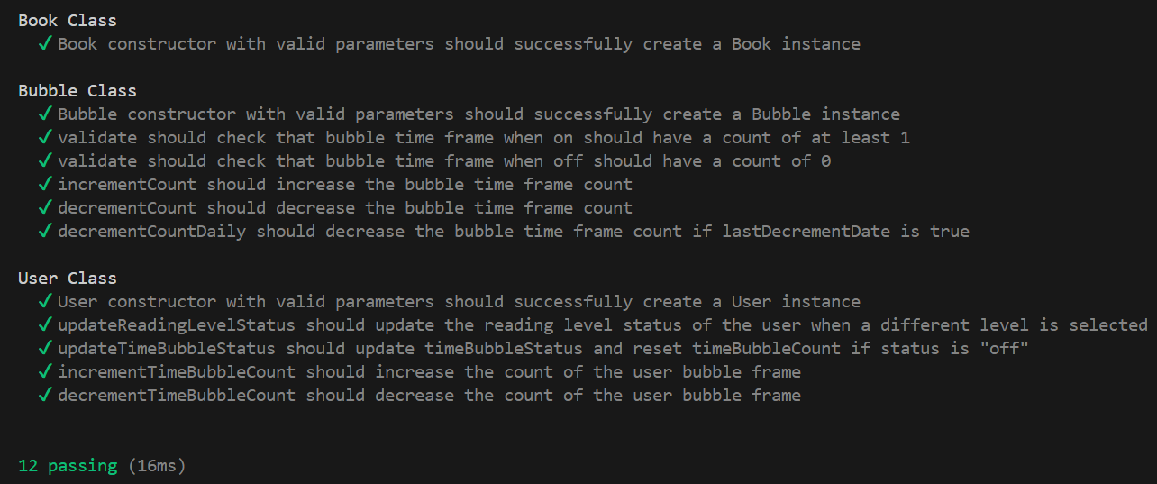Test Cases table is continued on [appendices 6.13]

## **Code Testing**

**WIP:** For TsundokuBR, I would like to deploy my tests onto a CI/CD pipeline, specifically using GitLab [43], the version control repository that I have been using to maintain my project. The next stage of my testing will require setting up runners so that the test script can run periodically to ensure the health of the code being committed.

## **User Evaluation**

During the development of the 3 features: Search for Book, Assign Time Bubble, and Assign Reading Level, potential users of TsundokuBR were asked to review the User Interface and the interactive wireframes during a real-time interview, I took note of their responses and applied the changes that could be made immediate as well as the changes that would be put into motion once the rest of the web application was developed and had more functionality.

During the interactive wireframe review users highlighted that they preferred that the settings for the reading level and time bubble did not require them to have to save it each time manually and suggested the idea of autosaving. Therefore, this feedback removed the save button on the “Time Bubble Menu” Page and the “Reading Level Menu” page. A question one of the users asked was about the functionality of the Reading Level, the user questioned why they had to select a reading level if the number of books being added and the time bubble frame was a suggestion, upon further feedback from users of different reading speeds and recreational time available I was able to conclude that “Light” and “Moderate” users would require a “Limit” to the number of books being added onto to the TBR shelf, it was made clear that users would benefit from smaller feasible goals and work their way up to a higher level when they felt comfortable, the time bubble, however, was commended by the users as the ability to turn it on and off at will remove the pressure of having “deadlines” which encouraged a more positive perspective compared to existing books apps in the market.

To conclude the UX UI review readers highlighted that the amount of time suggested for a single book at each different level was too small of an amount, even readers that chose a light reading level said that they were able to read an average length book within two weeks and that it was just finding time to read between work pr school which was the factor that affected their reading speed, therefore for this feedback for light and moderate levels I added a MAX book variable this was added to ensure that users were able to complete a feasible amount that felt rewarding.

## **Roadmap & Project Management**

GitLab Repo: <https://gitlab2.eeecs.qub.ac.uk/40297923/CSC3002_TBR_40297923>

Jira: <https://venniz.atlassian.net/jira/core/projects/NBP/board>

Using Jira for the TsundokuBR project management is beneficial due to its robust tools for tracking tasks, managing workflows, and ensuring team collaboration. Its customisation and integration ability along with development tools enhance productivity. The roadmap for TsundokuBR can be found in [appendices 6.14]. Roadmaps provide a strategic overview of the TBR’s goals, timeline, and key milestones, helping align priorities, and ensure goals are met [4].

**Sprint Number: 3**

* **Start**: Week_09 11/11/24
* **Duration**: 2 Weeks
* **Sprint Goal**: Environment, Google Books API, Project File Setup, and Frontend Dashboard Development
* **Clear Sprint Objectives**: Get the web application development for TsundokuBR started and set up the main point of entry for users.
* **Sprint Backlog**: Readme file setup.
  + **Task 1: Environment Setup**
    - Priority: High
    - Estimated Time: ½ a week
    - Status: Done
    - Milestones: Completion of downloading all required tools for project.
  + **Task 2: Google Books API Setup**
    - Priority: High
    - Estimated Time: ½ a week
    - Status: Done
    - Milestones: Completion of obtaining an API key.
  + **Task 3: Project File Setup**
    - Priority: Medium
    - Estimated Time: ½ a week
    - Status: Done
    - Milestones: Completion of structure showing clear indication of frontend and backend services.
  + **Task 4: Frontend Dashboard Development**
    - Priority: High
    - Estimated Time: 1 week
    - Status: Done
    - Milestones: Completion of design and development of user entry point.

**Sprint Number: 4**

* **Start**: Week_11 25/11/24
* **Duration**: 4 Weeks
* **Sprint Goal**: Backend Development, Frontend Development, and Integration of 2/3 functioning features
* **Clear Sprint Objectives**: Get the reading level and time bubble features implemented.
* **Sprint Backlog**: Project Brief write-up.
  + **Task 1: Frontend Development**
    - Priority: High
    - Estimated Time: 1 week
    - Status: Done
    - Milestones: Completion of frontend for time bubble and reading level.
  + **Task 2: Backend Development**
    - Priority: High
    - Estimated Time: 2 weeks
    - Status: Done
    - Milestones: Completion of backend for time bubble and reading level.
  + **Task 3: Frontend and Backend Integration**
    - Priority: High
    - Estimated Time: 1 week
    - Status: Done
    - Milestones: Completion of successful integration of components.

**Sprint Number: 5**

* **Start**: Week_11 25/11/24
* **Duration**: 4 Weeks
* **Sprint Goal**: Backend Unit Testing, Backend Development and Frontend Development
* **Clear Sprint Objectives**: Get the reading level and time bubble features tested, Get the API calls function for search for book implemented.
* **Sprint Backlog**: N/A
  + **Task 1: Frontend Development**
    - Priority: High
    - Estimated Time: 1 week
    - Status: Done
    - Milestones: Completion of unit testing time bubble and reading level backend functionality.
  + **Task 2: Frontend Development**
    - Priority: High
    - Estimated Time: 2 weeks
    - Status: Done
    - Milestones: Completion of frontend for navigation and search for books page and search for book API requests.
  + **Task 3: Backend Development**
    - Priority: Medium
    - Estimated Time: ½ a week
    - Status: Done
    - Milestones: Completion of implementation of Books, User and Levels classes required for TsundokuBR

## **Appendices**

1. **Gap Area Analysis**

*Table 1 Gap Area Analysis*

|  |  |  |  |  |  |
| --- | --- | --- | --- | --- | --- |
|  | **Goodreads** | **Fable** | **Bookshelf** | **Bookly** | **Bookmory** |
| **Facilitates adding books onto a shelf** | **x** | **x** | **x** | **x** | **x** |
| **Users can add a reading goal they wish to achieve** | **x** | **x** | **x** | **x** | **x** |
| **Users can adjust the length of their reading challenge** |  |  |  | **x** | **x** |
| **Prompts the user with periodic reminders to check in on their reading goal** |  | **x** | **x** | **x** |  |
| **Book selection from the unread shelf** |  |  |  |  |  |
| **Facilitates book journalling capabilities** |  |  |  | **x** | **x** |

*x = feature is addressed*

*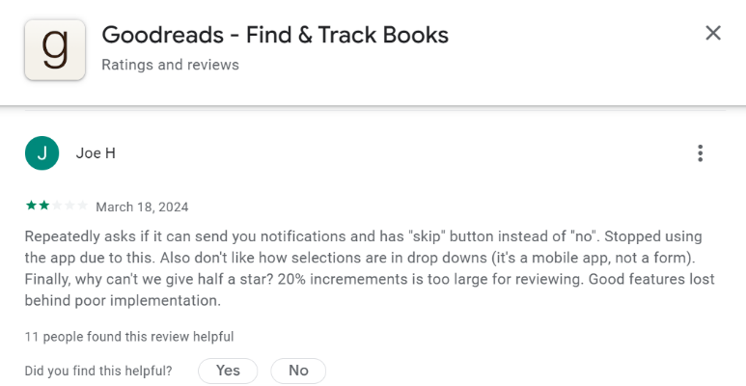Goodreads user review:*

*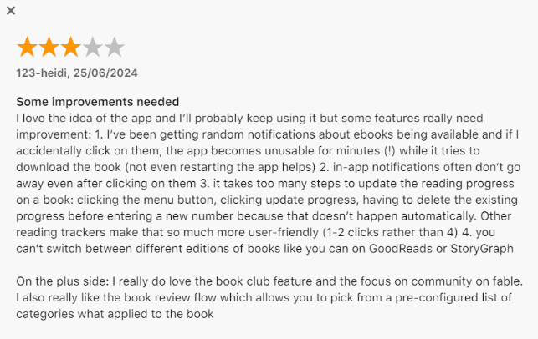Fable user review:*

*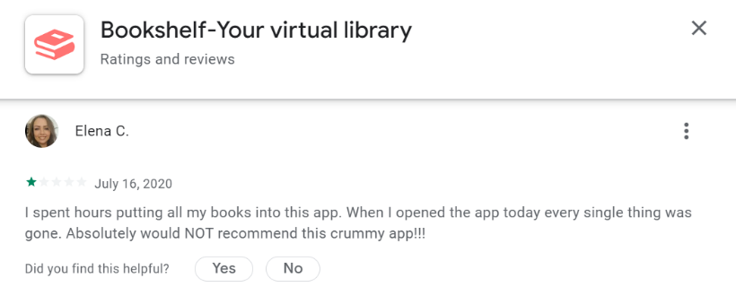Bookshelf user review:*

1. 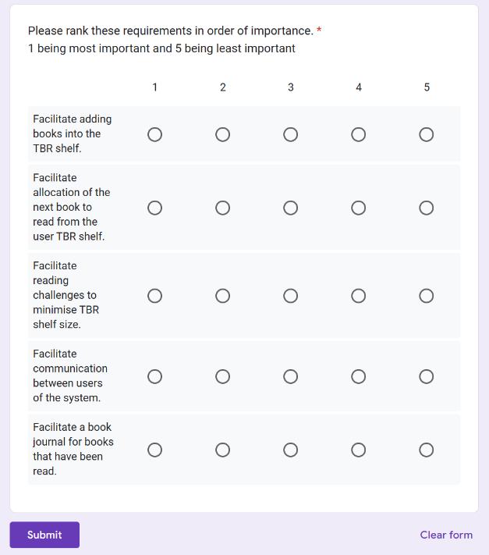**Requirement Prioritisation**

*Google Form: Requirement Prioritisation:*

1. **Mapping Functional Requirements to User Stories**

|  |  |  |  |
| --- | --- | --- | --- |
| **ID** | **Requirement** | Related User Story | Acceptance Criteria |
| **FRM03** | **Select A Reading Level** | **As a user, I want to select my reading level so that the app can adjust recommendations accordingly.** | **Given I am on the reading level selection page, when I choose a reading level, then my preference should be saved for future recommendations.** |
| **FRM04** | **Turn Time Bubble On/Off** | **As a user, I want to toggle the time bubble on or off to control how reading time is tracked.** | **Given I am on the time bubble settings page, when I toggle the time bubble switch, then the time bubble should be enabled or disabled accordingly.** |
| **FRM10** | **Add Book To TBR** | **As a user, I want to add a book to my TBR list so I can save it for future reading.** | **Given I am viewing a book’s details, when I select “Add to TBR,” then that book should appear on my TBR shelf.** |
| **FRM01** | **Create Account** | As a user, I want to create an account so that I can access the system with my unique credentials. | Given I am on the create account page, when I enter my email and password and submit, then my account should be created, and I should receive a confirmation. |
| **FRM02** | **Login To Account** | As a user, I want to log in so that I can access my account and saved information. | Given I am on the login page, when I enter my credentials and submit, then I should be logged into my account and redirected to the dashboard. |
| **FRM05** | **Allocate A Reading Sequence** | As a user, I want to set a reading sequence for my TBR list so I can manage the order in which I read. | Given I am on the TBR list page, when I arrange books in a specific order, then my reading sequence should be saved and displayed accordingly. |
| **FRM06** | **Start Book** | As a user, I want to select “Start Book” to begin reading a book from my TBR list. | Given I am on my TBR list, when I select “Start Book” for a specific book, then that book should be marked as the current book in my reading session. |
| **FRM07** | **Finish Book** | As a user, I want to mark a book as finished to move it from my TBR list to my Read shelf. | Given I am reading a book, when I select “Finish Book,” then that book should be moved to the Read shelf and removed from the TBR list. |
| **FRM08** | **Search For Book** | As a user, I want to search for books within the system so I can find new books to read. | Given I am on the search page, when I enter search terms and submit, then I should see relevant book results matching my search criteria. |
| **FRM09** | **Select Book** | As a user, I want to select a book from my search results or lists to view more details. | Given I have search results or a list of books, when I select a book, then I should be directed to the book’s detail page with relevant information. |
| **FRM11** | **Remove Book From TBR** | As a user, I want to remove a book from my TBR list if I no longer wish to read it. | Given I am viewing my TBR list, when I choose to remove a book, then that book should be removed from my TBR shelf. |
| **FRS01** | **Go To “Login” Page** | As a user, I want to navigate to the login page to access my account. | Given I am on any page, when I select the option to go to the login page, then I should be redirected to the login screen. |
| **FRS02** | **Go To “Create Account” Page** | As a user, I want to navigate to the create account page so I can register. | Given I am on any page, when I choose the create account option, then I should be redirected to the registration screen. |
| **FRS03** | **Go To “Reading Level Menu” Page** | As a user, I want to navigate to the reading level menu so I can set my reading preferences. | Given I am on any page, when I select the reading level menu option, then I should be redirected to the reading level selection page. |
| **FRS04** | **Go To “Time Bubble Menu” Page** | As a user, I want to navigate to the time bubble settings page to manage reading time tracking. | Given I am on any page, when I select the time bubble menu option, then I should be redirected to the time bubble settings page. |
| **FRS05** | **Go To “Book Menu” Page** | As a user, I want to navigate to the book menu to manage my reading lists. | Given I am on any page, when I select the book menu option, then I should be redirected to the book menu page. |
| **FRS06** | **Go To “Read Shelf” Page** | As a user, I want to navigate to my Read shelf to view books I’ve completed. | Given I am on any page, when I select the Read shelf option, then I should be redirected to the Read shelf page. |
| **FRS07** | **Go To “TBR Shelf” Page** | As a user, I want to navigate to my TBR shelf to view books I plan to read. | Given I am on any page, when I select the TBR shelf option, then I should be redirected to the TBR shelf page. |
| **FRS08** | **Log Out** | As a user, I want to log out of my account to secure my information. | Given I am logged in, when I select the log out option, then I should be logged out and redirected to the homepage. |
| **FRS09** | **Go To “Dashboard” Page** | As a user, I want to go to the dashboard to access an overview of my reading activity. | Given I am on any page, when I select the dashboard option, then I should be redirected to the dashboard page. |
| **FRS10** | **Add A Time Bubble Frame** | As a user, I want to set a time bubble duration to track my reading time. | Given I am on the time bubble settings page, when I choose a duration, then that time should be saved as my current reading time goal. |
| **FRS11** | **Start Time Bubble Countdown** | As a user, I want to start the time bubble countdown to track my reading session. | Given I am on the time bubble settings page, when I start the countdown, then the timer should begin, and time should be tracked until I stop it. |
| **FRS12** | **Stop Time Bubble Countdown** | As a user, I want to stop the time bubble countdown when I finish my reading session. | Given the time bubble countdown is active, when I choose to stop it, then the countdown should pause and save my tracked time. |
| **FRS13** | **Go To “Search For Book” Page** | As a user, I want to navigate to the search page so I can look for books. | Given I am on any page, when I select the search for books option, then I should be redirected to the search page. |
| **FRC01** | **Display The TBR List** | As a user, I want to view the list of books on my TBR shelf to manage my reading queue. | Given I am on the TBR shelf, when I look at the list, then I should see all books I have added to my TBR shelf in the set sequence. |
| **FRC02** | **Display The Read List** | As a user, I want to view the list of books on my Read shelf to see what I have completed. | Given I am on the Read shelf, when I view the list, then I should see all books I have marked as finished. |
| **FRC03** | **Add Note To Book** | As a user, I want to add notes to the books I have read to keep track of thoughts or insights. | Given I am viewing a book’s detail page, when I add a note, then the note should be saved and associated with that book. |
| **FRC04** | **Display The Note List** | As a user, I want to view the list of notes I have made on my books to review my thoughts. | Given I am on the notes page, when I view my notes list, then I should see all notes I have saved across my books. |
| **FRW01** | **Request A Different Book** | As a user, I won’t have the option to request a different book from my TBR list once it’s set. | Given I am viewing my TBR shelf, then there should be no option available to request a different book from my TBR list. |
| **FRW02** | **Delete Book From Read Shelf** | As a user, I won’t have the option to delete books from my Read shelf, so that my record of completed books remains intact. | Given I am viewing my Read shelf, then there should be no option available to delete books from my Read shelf. |
| **FRW03** | **Edit Note Entry** | As a user, I won’t have the option to edit previous notes once they’re saved. | Given I have saved a note, then there should be no option available to edit that note. |
| **FRW04** | **Delete Note Entry** | As a user, I won’t have the option to delete previous notes once they’re saved. | Given I have saved a note, then there should be no option available to delete that note. |

*Table 3 Mapping Functional Requirements to User Stories*

|  |  |  |  |
| --- | --- | --- | --- |
| System Component | Technical Choice | Reason of Choice | Alternative |
| Frontend Framework | React | React is increasingly a popular choice within the software development community due to its intuitive and responsive user interface. React is flexible and integrates well with other libraries and frameworks. | Vue.js |
| Frontend CSS Framework | React Bootstrap | React Bootstrap allows for seamless integration especially when combined with React, this allows for easy implementation of responsive and appealing interfaces without the need for complex CSS. | Tailwind |
| Backend & Integration API | Node.js & Express.js | Node.js and Express.js along with React enables seamless JavaScript development across both the frontend and backend, ensuring efficient performance and easier code maintenance. Their powerful ecosystem and non-blocking architecture enhance scalability, perfect for modern web applications. | Python & FastAPI |
| Database | MySQL | MySQL is popular and widely used in the industry due to its reliability and efficiency, due to its popularity MySQL is well documented which offers plenty of resources. | MongoDB |
| Book API | Google Books API | Google Books provides a comprehensive repository of book data with few limitations, its interoperability makes it flexible and easy to integrate with different applications. | Open Library |
| IDE/Editor | VSCode | VSCode has an intuitive interface that is easy to use. Its extensive array of extensions allow for customisation and enhanced functionality yet is lightweight and fast, VSCode also offers the smooth integration with Git which can aid in version control and automation. | Visual Studio |

1. **Technical Choice Selection**

*Table 4 Technical Choices*

1. **Paper Prototype Diagrams**

*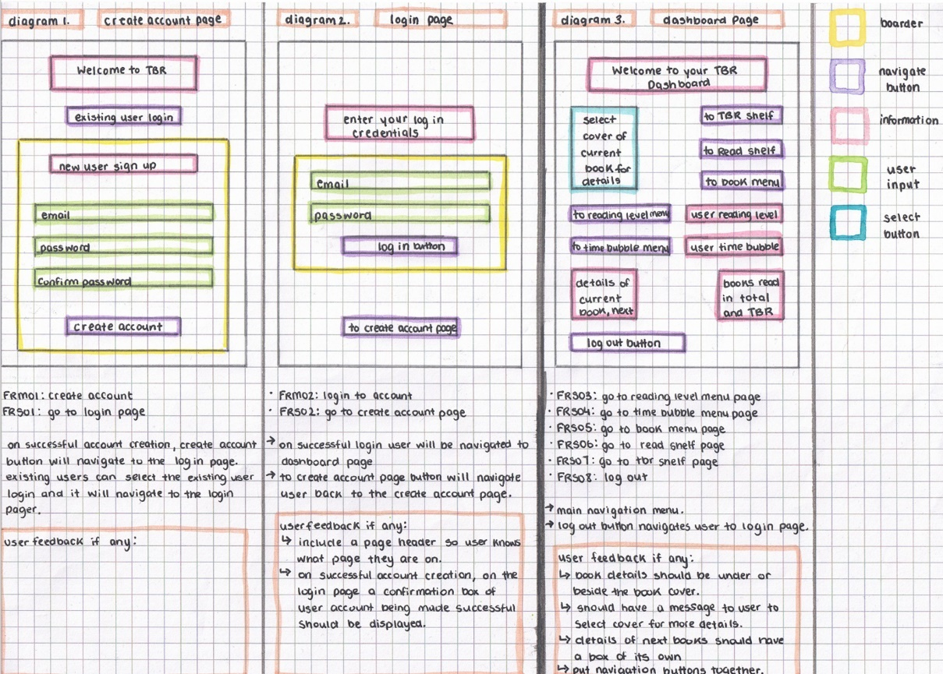Paper Prototype Diagrams with User Feedback 1, 2, and 3:*

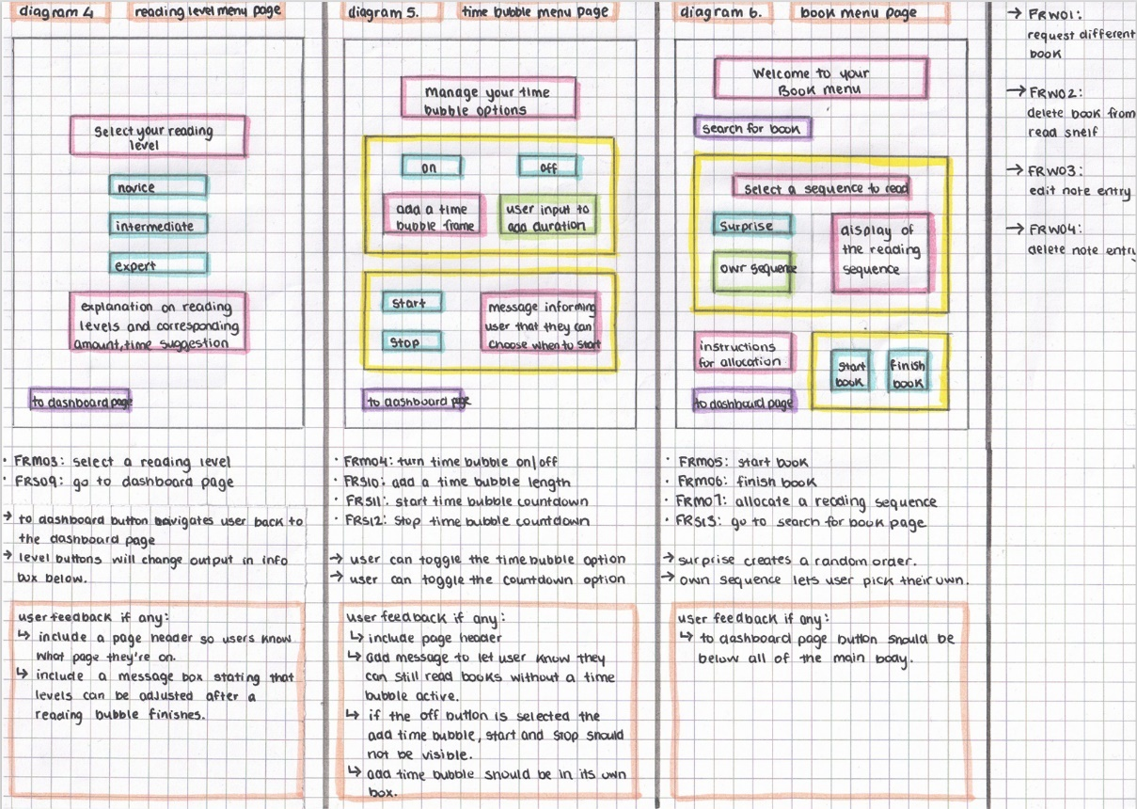

*Paper Prototype Diagrams with User Feedback 4, 5, and 6:*

*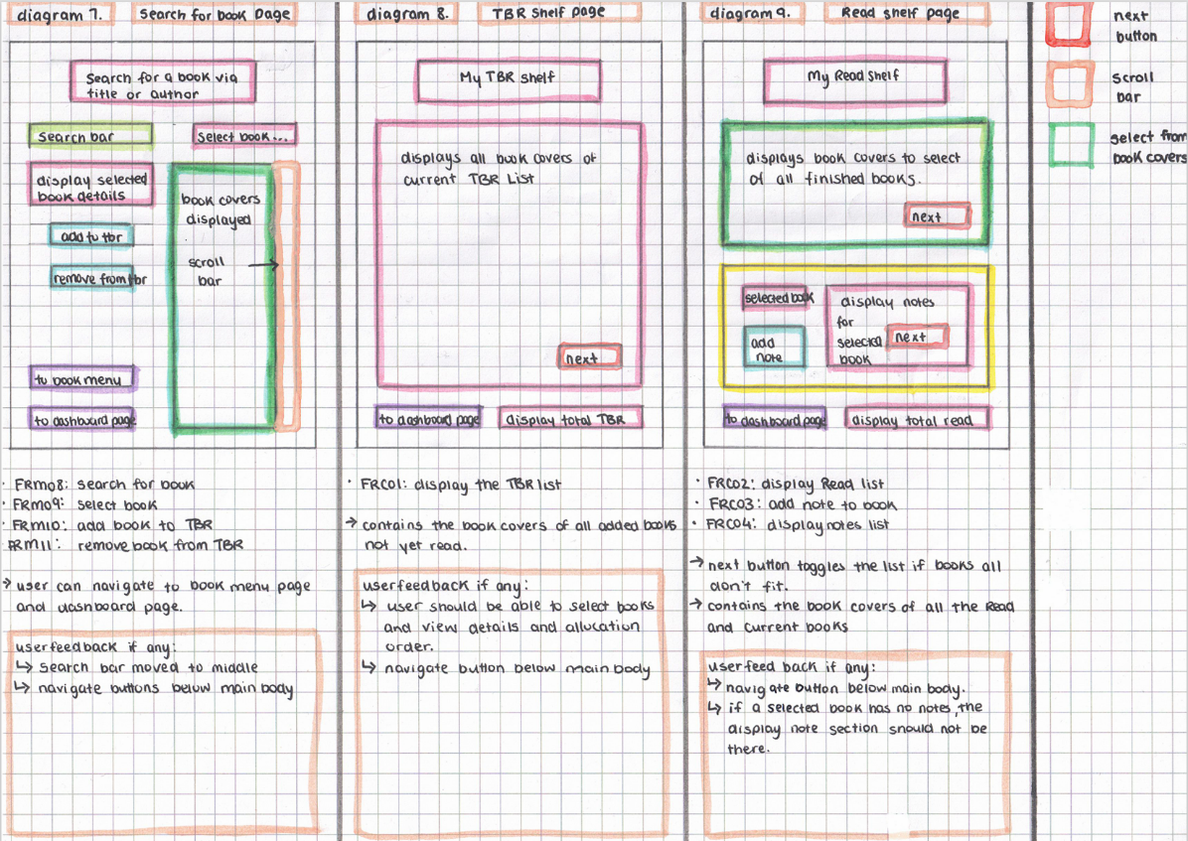Paper Prototype Diagrams with User Feedback 7, 8, and 9*

1. **User Flow Diagrams with User Feedback**

## *draw.io: User Flow Diagram: Selecting a Reading Level*

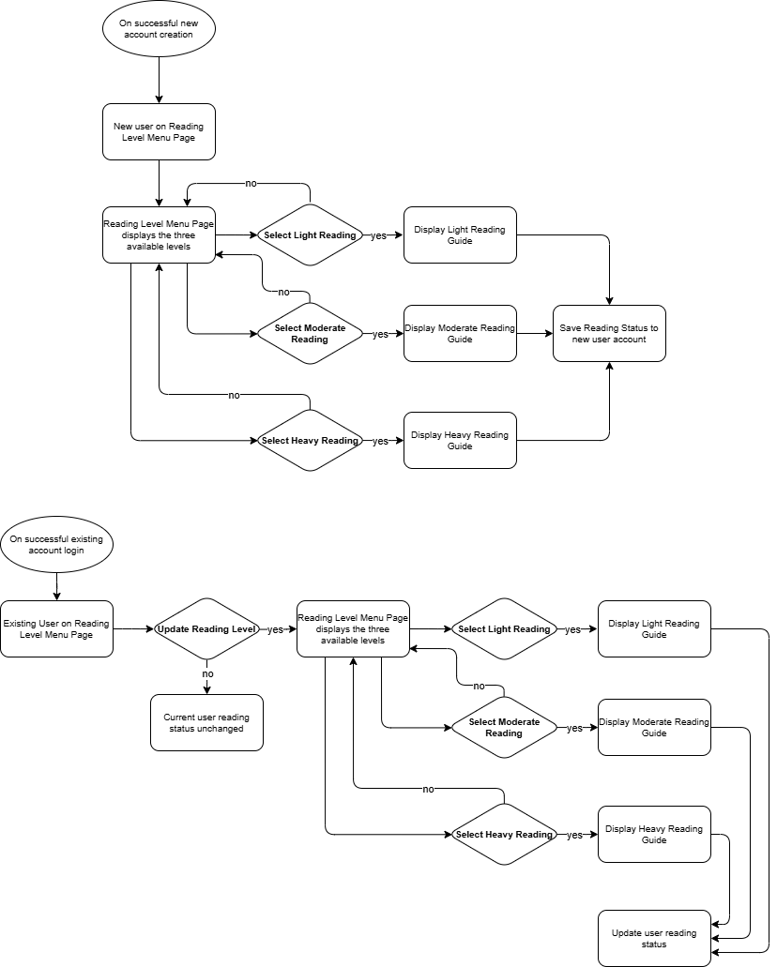



## *draw.io: User Flow Diagram: Turn Time Bubble On/Off*

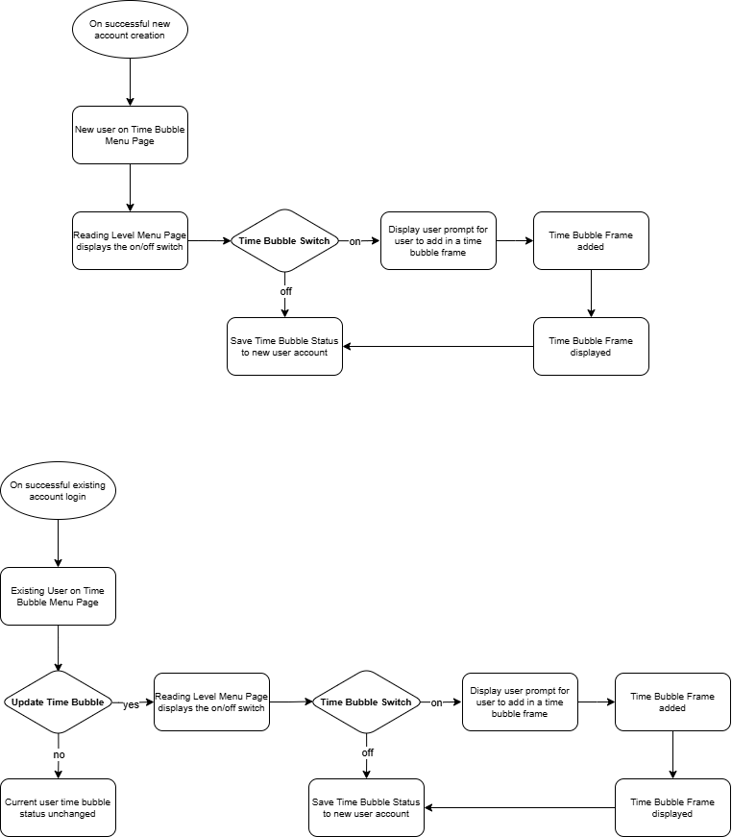



1. **Wireframes**

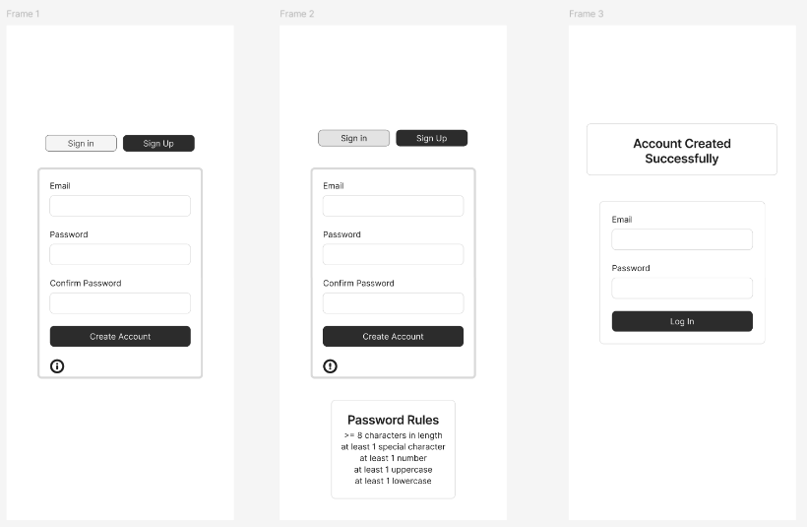*Figma: Interactive Wireframes*

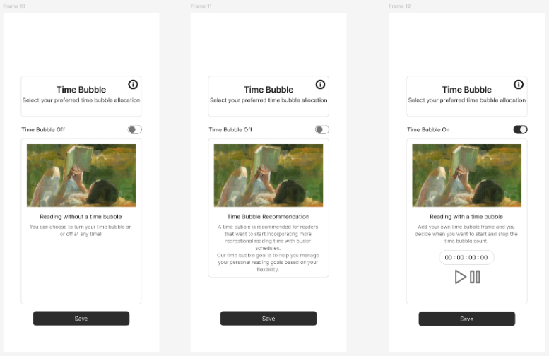

## 

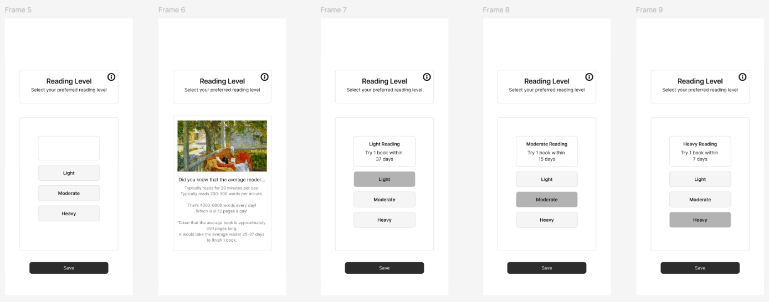

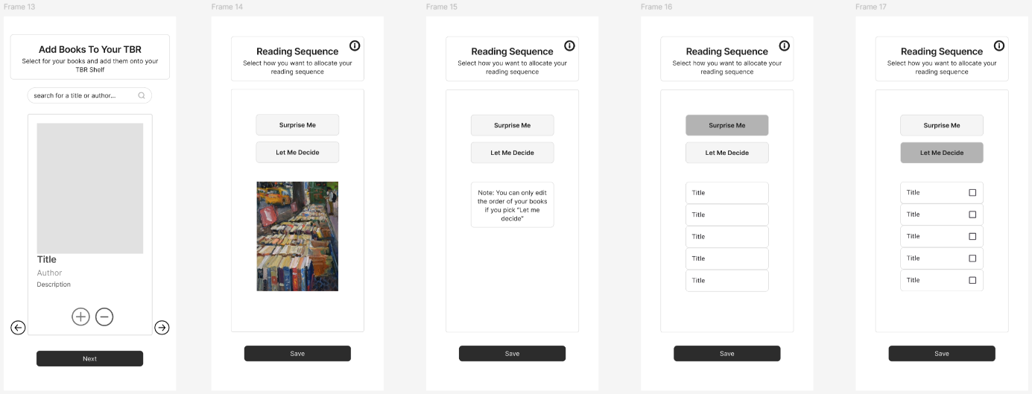

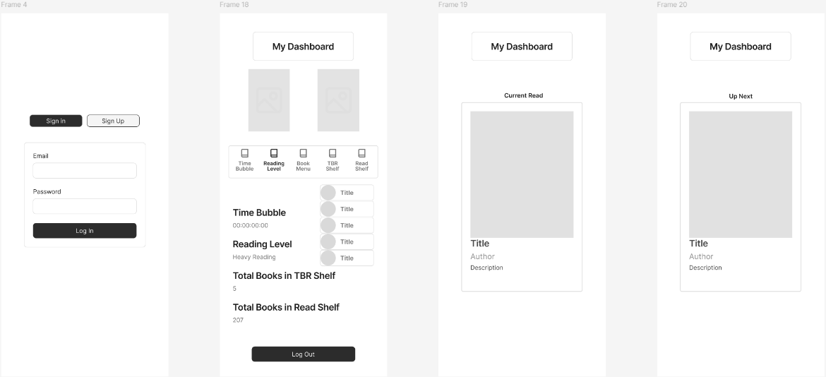

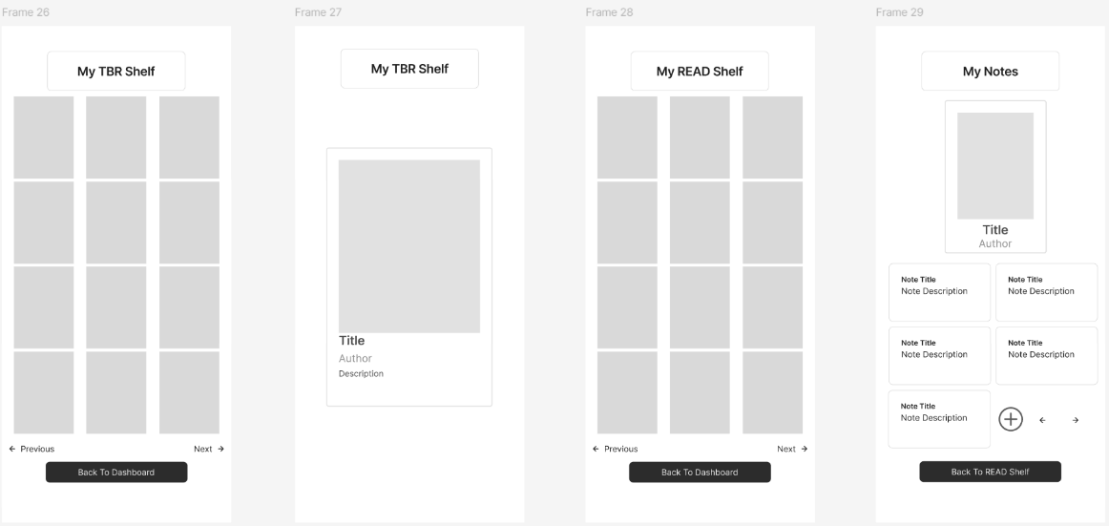

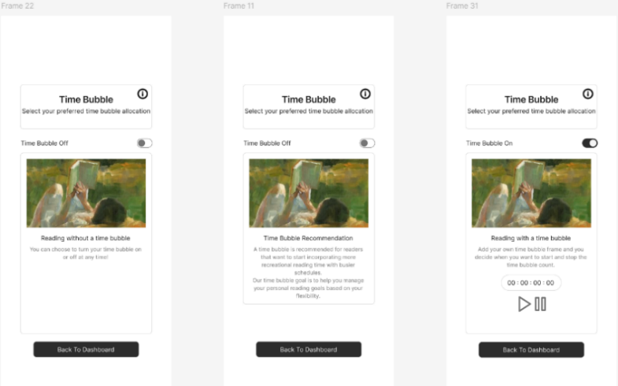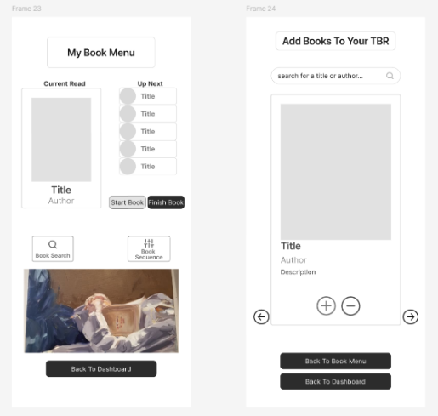

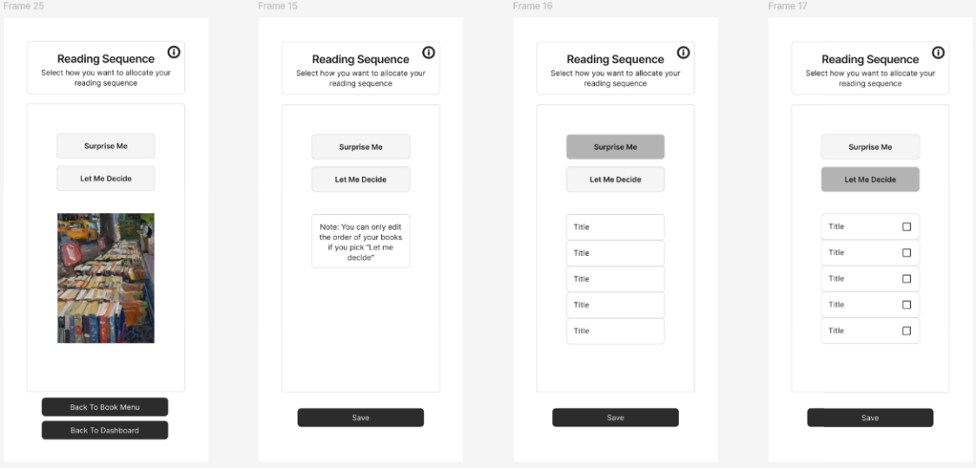

1. **Use-Case and Use-Case Diagrams**

*draw.io: Use-Case Diagram: Select Reading Level, Toggle Time Bubble Switch, Add Book to TBR Shelf*

*Continuation of Use-Case Use-Case Tables 5 - 37*

|  |  |
| --- | --- |
| Use Case Subject | Accounts & Settings |
| Use Case ID | UC-AS-01 |
| Use Case Name | Create Account |
| Description | Allow user to create an account by providing unique credentials for email and passwords. |
| Actor | User |
| Preconditions | * User is new and has no pre-existing account. * User is on the “Create Account” page * User requires a unique email and password. * User requires to repeat password for validation. |
| Process | 1. User navigates to the "Create Account" page. 2. User enters required details (email, password). 3. System validates the provided information (checks email & password format). 4. If valid, the system creates the account and stores the user's information. 5. System displays a success message and redirects to the login page. |
| Postconditions | * New user account is created and is stored in the system. * New user is redirected to login page. |
| Alternate Flow | * Invalid information results in an error message displayed. |
| Use Case Notes | * Associated Functional Requirements: FRM01 * Check the database for any existing emails that the new user is trying to sign up with. |

|  |  |
| --- | --- |
| Use Case Subject | Accounts & Settings |
| Use Case ID | UC-AS-02 |
| Use Case Name | Login to Account |
| Description | Allow user to login to an account using their credentials. |
| Actor | User |
| Preconditions | * User has an existing account and is logged in. * User is on the “Dash |
| Process | 1. User navigates to the "Login" page. 2. User enters their email and password. 3. System verifies the credentials. 4. If valid, the system logs the user in and redirects them to the dashboard. |
| Postconditions | * User is logged in to their account. * User is redirected to the dashboard page. |
| Alternate Flow | * Invalid information results in an error message displayed. * The first time a user logs in will redirect to setup, user is redirected to the select reading level menu page. |
| Use Case Notes | * Associated Functional Requirements: FRM02 * Should have a check that counts the number of times a user will login. |

|  |  |
| --- | --- |
| Use Case Subject | Accounts & Settings |
| Use Case ID | UC-AS-03 |
| Use Case Name | Logout of Account |
| Description | Allows user to logout of their account. |
| Actor | User |
| Preconditions | * User is logged in. * User is on the “Dashboard” page. |
| Process | 1. User selects "Log Out." 2. System logs out the user, and redirects to the login page. |
| Postconditions | * User is logged out. * User is then redirected to the log in page. |
| Alternate Flow | * A user not logged in will remain on the log in page. |
| Use Case Notes | * Associated Functional Requirements: FRS08 * The user should be prompted to confirm that they want to logout. |

|  |  |
| --- | --- |
| Use Case Subject | Accounts & Settings |
| Use Case ID | UC-AS-04 |
| Use Case Name | Select Reading Level |
| Description | Allows user to select and edit at any time their preferred reading level from the available options: Novice, Intermediate, and Expert. |
| Actor | User |
| Preconditions | * User is logged in. * User is on the Reading Level Menu Page. |
| Process | 1. User navigates to the "Reading Level Menu" page. 2. User selects their reading level from the available options. 3. System saves the selected reading level to the user’s profile. 4. System confirms the selection with a success message. |
| Postconditions | * Selected reading level is saved and displayed onto the user’s profile. * Message is displayed for the user that has a suggested book amount for a suggested time bubble frame. |
| Alternate Flow | * Leaving the reading level menu page with an unselected reading level will result in an error message displayed. |
| Use Case Notes | * Associated Functional Requirements: FRM03 * The user at any time should be allowed to select a different reading level. * User can add less than or equal to the number of books suggested for Novice and Intermediate, and the expert level doesn’t have restrictions. |

|  |  |
| --- | --- |
| Use Case Subject | Accounts & Settings |
| Use Case ID | UC-AS-05 |
| Use Case Name | Turn Time Bubble On/Off |
| Description | Allow users to toggle the time bubble setting on or off. |
| Actor | User |
| Preconditions | * User is logged in. * User is on the “Time Bubble Menu” page. |
| Process | 1. User navigates to the "Time Bubble Menu" page. 2. User toggles the time bubble feature on or off. 3. System saves the setting and confirms the change. |
| Postconditions | * Time bubble setting is saved in the user’s profile. |
| Alternate Flow | * Changes not made will result in no change. * From on to off will remove the time bubble frame previously added. * From off to on will prompt user to add a time bubble frame. |
| Use Case Notes | * Associated Functional Requirements: FRM04 * Allowing the user the freedom to be able to read books even if there is no designated time bubble frame allocated. |

|  |  |
| --- | --- |
| Use Case Subject | Accounts & Settings |
| Use Case ID | UC-AS-06 |
| Use Case Name | Add Time Bubble |
| Description | Allows users to set a duration for the time bubble setting. |
| Actor | User |
| Preconditions | * User is logged in. * User is on the “Time Bubble Menu” page. * User time bubble toggle is switched to on. |
| Process | 1. User navigates to the Time Bubble Menu page. 2. User selects "Add Time Bubble Frame" and sets a duration. 3. System saves the selected duration and confirms the update. |
| Postconditions | * Duration for time bubble frame is set and saved to the user’s profile. * User is displayed a message to start the bubble whenever they want. |
| Alternate Flow | Invalid duration entered will result in an error message being displayed. |
| Use Case Notes | * Associated Functional Requirements: FRS10 * User at anytime should be allowed to stop the time bubble frame and start it again when they want given, they have time remaining. * User at any time can change the time bubble frame duration. |

|  |  |
| --- | --- |
| Use Case Subject | Accounts & Settings |
| Use Case ID | UC-AS-07 |
| Use Case Name | Start Time Bubble |
| Description | Allows user to start the time bubble count down. |
| Actor | User |
| Preconditions | * User is logged in. * User is on the “Time Bubble Menu” page. * User time bubble toggle is switched to on. * User has added a time bubble duration. |
| Process | 1. User navigates to the Time Bubble Menu page. 2. User selects "Start Time Bubble." 3. System starts the countdown and confirms the action. |
| Postconditions | * Time bubble countdown starts and is displayed. |
| Alternate Flow | * No bubble frame added will result in an error message being displayed. |
| Use Case Notes | * Associated Functional Requirements: FRS11 * User can start the bubble whenever they want. |

|  |  |
| --- | --- |
| Use Case Subject | Accounts & Settings |
| Use Case ID | UC-AS-08 |
| Use Case Name | Stop Time Bubble |
| Description | Allows user to stop the time bubble count down. |
| Actor | User |
| Preconditions | * User is logged in. * User is on the “Time Bubble Menu” page. * User time bubble toggle is switched to on. * User has added a time bubble duration and has started it. * Time bubble is actively counting down. |
| Process | 1. User navigates to the Time Bubble Menu page. 2. User selects "Stop Time Bubble." 3. System stops the countdown and confirms the action. |
| Postconditions | Time bubble countdown stops and is shown on the display |
| Alternate Flow | No bubble frame added will result in an error message being displayed. |
| Use Case Notes | * Associated Functional Requirements: FRS12 * User can stop the bubble whenever they want. |

|  |  |
| --- | --- |
| Use Case Subject | Accounts & Settings |
| Use Case ID | UC-AS-09 |
| Use Case Name | Allocate Reading Sequence |
| Description | Allows user to select what way they want to order the books within their TBR shelf. |
| Actor | Users |
| Preconditions | * User is logged in. * User is on the “Book Menu” page. * User has books in their TBR shelf. |
| Process | 1. User navigates to the "Book Menu" page. 2. User selects from the options surprise or own sequence. 3. System saves the sequence and displays the order. |
| Postconditions | * Reading sequence saved and their order is displayed. |
| Alternate Flow | * Selecting surprise sequence will result in the system allocating the order. * Selecting own sequence prompts user to order the TBR shelf in any order they want. * No books on the TBR shelf will result in an error message being displayed. |
| Use Case Notes | * Associated Functional Requirements: FRM05 * User at any time should be able to rearrange the reading order of their books as long as they selected own sequence. |

|  |  |
| --- | --- |
| Use Case Subject | Accounts & Settings |
| Use Case ID | UC-AS-10 |
| Use Case Name | Start Book |
| Description | Allows user to start reading a book by marking it as “current” from the TBR list and using the allocation sequence. |
| Actor | User |
| Preconditions | * User is logged in. * User has at least one book on the TBR shelf. * User has allocated a reading sequence. * User is on the “Book Menu” page. |
| Process | 1. User navigates to the “Book Menu”. 2. User selects "Start Book." 3. System marks the book at the top of the list as “current”. |
| Postconditions | * Current book is saved and displayed on the dashboard page. |
| Alternate Flow | * Having no books on the TBR shelf will result in an error message being displayed. * Having no sequence allocated will result in an error message being displayed |
| Use Case Notes | * Associated Functional Requirements: FRM06 * User will not be able to request a new book. |

|  |  |
| --- | --- |
| Use Case Subject | Accounts & Settings |
| Use Case ID | UC-AS-11 |
| Use Case Name | Finish Book |
| Description | Allows user to start reading a book by marking it as “current” from the TBR list and using the allocation sequence. |
| Actor | User |
| Preconditions | * User is logged in. * User has a book marked as current that is active. * User is on the “Book Menu” page. |
| Process | 1. User navigates to the “Book Menu”. 2. User selects "Finish Book." 3. System marks the book as finished and adds it onto the TBR shelf. |
| Postconditions | * Book is removed from TBR and current and is added and displayed on the Read shelf. |
| Alternate Flow | * Having no “current” will result in an error message being displayed. |
| Use Case Notes | * Associated Functional Requirements: FRM07 * Once a book has been marked as current and or finished it should no longer be able to be removed as books on the TBR shelf can be removed. |

|  |  |
| --- | --- |
| Use Case Subject | Navigation & Displays |
| Use Case ID | UC-ND-01 |
| Use Case Name | Go To Create Account Page |
| Description | Allows users to navigate to the “Create Account” page. |
| Actor | User |
| Preconditions | * Users is on the “Login” page. |
| Process | 1. User selects the "Sign Up" option. 2. System redirects the user to the Create Account page. |
| Postconditions | * User is navigated to the “Create Account” page. |
| Alternate Flow | * N/A |
| Use Case Notes | * Associated Functional Requirements: FRS02 * Allow for a switch between create account and login to account just in case user makes a mistake and selects the wrong option. |

|  |  |
| --- | --- |
| Use Case Subject | Navigation & Displays |
| Use Case ID | UC-ND-02 |
| Use Case Name | Go To Login Page |
| Description | Allows users to navigate to the “Login” page. |
| Actor | User |
| Preconditions | * User is on the “Create Account” page. |
| Process | 1. User clicks on the "Login" option. 2. System redirects the user to the Login page. |
| Postconditions | * User is navigated to the “Login” page. |
| Alternate Flow | * User can also navigate to login page when they logout of their account. |
| Use Case Notes | * Associated Functional Requirements: FRS01 |

|  |  |
| --- | --- |
| Use Case Subject | Navigation & Displays |
| Use Case ID | UC-ND-03 |
| Use Case Name | Go To Reading Level Menu Page |
| Description | Allows users to navigate to the “Reading Level Menu” page. |
| Actor | User |
| Preconditions | * User is logged in. * User is on “Dashboard” page |
| Process | 1. User selects the "Reading Level Menu" option. 2. System displays the Reading Level Menu page. |
| Postconditions | * User is navigated to the “Reading Level Men” page. |
| Alternate Flow | * Upon first time logging in the user will be redirected to this page as part of initial set up. |
| Use Case Notes | * Associated Functional Requirements: FRS03 |

|  |  |
| --- | --- |
| Use Case Subject | Navigation & Displays |
| Use Case ID | UC-ND-04 |
| Use Case Name | Go To Time Bubble Menu Page |
| Description | Allows users to navigate to the “Time Bubble Menu” page. |
| Actor | User |
| Preconditions | * User is logged in. * User is on “Dashboard” page |
| Process | 1. User selects the "Time Bubble Menu" option. 2. System displays the Time Bubble Menu page. |
| Postconditions | * User is navigated to the “Time Bubble Menu” page. |
| Alternate Flow | * Upon first time logging in the user will be redirected to this page as part of initial set up. |
| Use Case Notes | * Associated Functional Requirements: FRS04 |

|  |  |
| --- | --- |
| Use Case Subject | Navigation & Displays |
| Use Case ID | UC-ND-05 |
| Use Case Name | Go To Dashboard Page |
| Description | Allows users to navigate to the “Dashboard” page. |
| Actor | User |
| Preconditions | * User is logged in. * User is on any other page except create account, login, and dashboard. |
| Process | 1. User selects the "Dashboard" option. 2. System displays the Dashboard page. |
| Postconditions | * User is navigated to the “Dashboard” page. |
| Alternate Flow | * N/A |
| Use Case Notes | * Associated Functional Requirements: FRS09 |

|  |  |
| --- | --- |
| Use Case Subject | Navigation & Displays |
| Use Case ID | UC-ND-06 |
| Use Case Name | Go To Book Menu Page |
| Description | Allows users to navigate to the “Book Menu” page. |
| Actor | User |
| Preconditions | * User is logged in. * User is on “Dashboard” page |
| Process | 1. User selects the "Book Menu" option. 2. System displays the Book Menu page. |
| Postconditions | * User is navigated to the “Book Menu” page. |
| Alternate Flow | * User can be coming from “Search For Book” page. |
| Use Case Notes | * Associated Functional Requirements: FRS05 * Being on “Search For Book” page is derived from the “Book Menu” page. |

|  |  |
| --- | --- |
| Use Case Subject | Navigation & Displays |
| Use Case ID | UC-ND-07 |
| Use Case Name | Go To Search For Book Page |
| Description | Allows users to navigate to the “Search For Book” page. |
| Actor | User |
| Preconditions | * User is logged in. * User is on “Book Menu” page |
| Process | 1. User selects the "Search For Book" option. 2. System displays the Search For Book page. |
| Postconditions | * User is navigated to the “Search For Book” page. |
| Alternate Flow | * N/A |
| Use Case Notes | * Associated Functional Requirements: FRS13 |

|  |  |
| --- | --- |
| Use Case Subject | Navigation & Displays |
| Use Case ID | UC-ND-08 |
| Use Case Name | Go To TBR Shelf Page |
| Description | Allows users to navigate to the “TBR Shelf” page. |
| Actor | User |
| Preconditions | * User is logged in. * User is on “Dashboard” page |
| Process | 1. User selects the "TBR Shelf" option. 2. System displays the TBR Shelf page. |
| Postconditions | * User is navigated to the “TBR Shelf” page. |
| Alternate Flow | * N/A |
| Use Case Notes | * Associated Functional Requirements: FRS07 |

|  |  |
| --- | --- |
| Use Case Subject | Navigation & Displays |
| Use Case ID | UC-ND-09 |
| Use Case Name | View TBR Books |
| Description | Allow users to view all the books on their TBR Shelf. |
| Actor | User |
| Preconditions | * User is logged in. * User is on “TBR Shelf” page |
| Process | 1. User navigates to the TBR Shelf page. 2. System displays all books in the TBR list. |
| Postconditions | * User is displayed the TBR books. |
| Alternate Flow | * N/A |
| Use Case Notes | * Associated Functional Requirements: FRC01 |

|  |  |
| --- | --- |
| Use Case Subject | Navigation & Displays |
| Use Case ID | UC-ND-10 |
| Use Case Name | Go To Read Shelf Page |
| Description | Allows users to navigate to the “Read Shelf” page. |
| Actor | User |
| Preconditions | * User is logged in. * User is on “Dashboard” page |
| Process | 1. User selects the "Read Shelf" option. 2. System displays the Read Shelf page. |
| Postconditions | * User is navigated to the “Read Shelf” page. |
| Alternate Flow | * An empty shelf will be displayed if no books are left or have been added to the shelf. |
| Use Case Notes | * Associated Functional Requirements: FRS06 |

|  |  |
| --- | --- |
| Use Case Subject | Navigation & Displays |
| Use Case ID | UC-ND-11 |
| Use Case Name | View Read Books |
| Description | Allow users to view all the books on their Read Shelf. |
| Actor | User |
| Preconditions | * User is logged in. * User is on “Read Shelf” page |
| Process | 1. User navigates to the Read Shelf page. 2. System displays all books in the Read list. |
| Postconditions | * User is displayed the Read books. |
| Alternate Flow | * An empty shelf will be displayed if no books have been finished yet. |
| Use Case Notes | * Associated Functional Requirements: FRC02 |

|  |  |
| --- | --- |
| Use Case Subject | Navigation & Displays |
| Use Case ID | UC-ND-12 |
| Use Case Name | View Notes From Read Books |
| Description | Allow users to view all the notes from the books on their Read Shelf. |
| Actor | User |
| Preconditions | * User is logged in. * User is on “Read Shelf” page * User has selected a book from the Read shelf |
| Process | 1. User navigates to the Read Shelf page. 2. System displays all books in the Read list. 3. User selects a book from the Read shelf list. 4. System displays the notes associated with the book. |
| Postconditions | User is displayed the notes associated with the book. |
| Alternate Flow | * No notes are associated with the book will result in a prompt to add notes if the user wants. |
| Use Case Notes | * Associated Functional Requirements: FRC04 * A user doesn’t have to add notes to books if they do not wish to. |

|  |  |
| --- | --- |
| Use Case Subject | Books & Notes |
| Use Case ID | UC-BN-01 |
| Use Case Name | Search For A Book |
| Description | Allows users to search for books in the system's catalogue. |
| Actor | User |
| Preconditions | * User is logged in. * User is on the "Search for Book" page. |
| Process | 1. User navigates to the "Search for Book" page. 2. User enters keywords (e.g., title or author). 3. System retrieves and displays matching books. |
| Postconditions | * System displays search results based on the user input. |
| Alternate Flow | * If a book is not in the catalogue, it will display a no results found message. |
| Use Case Notes | * Associated Functional Requirements: FRM08 |

|  |  |
| --- | --- |
| Use Case Subject | Books & Notes |
| Use Case ID | UC-BN-02 |
| Use Case Name | Select A Book |
| Description | Allows users to select a book from search results or lists to view details. |
| Actor | User |
| Preconditions | * User is logged in and viewing a list of books. |
| Process | 1. User views a list of books (from search results or shelf lists). 2. User selects a book. 3. System displays the selected book’s details. |
| Postconditions | * System displays detailed information for the selected book. |
| Alternate Flow | * N/A |
| Use Case Notes | * Associated Functional Requirements: FRM09 |

|  |  |
| --- | --- |
| Use Case Subject | Books & Notes |
| Use Case ID | UC-BN-03 |
| Use Case Name | Add Book To TBR Shelf |
| Description | Allows users to add a book to their TBR shelf. |
| Actor | User |
| Preconditions | * User is logged in. * User is on the “Search For Book” page. * User has searched for a book and has selected a book from the display. |
| Process | 1. User views the details of a selected book. 2. User clicks "Add to TBR." 3. System adds the book to the TBR shelf and confirms success. |
| Postconditions | * Book is added to the user's TBR shelf. |
| Alternate Flow | * Book not added to the TBR shelf because it has already been added. |
| Use Case Notes | * Associated Functional Requirements: FRM10 * Add a check to ensure unique book IDs cannot be added twice but different editions can. |

|  |  |
| --- | --- |
| Use Case Subject | Books & Notes |
| Use Case ID | UC-BN-04 |
| Use Case Name | Remove Book From TBR Shelf |
| Description | Allows users to remove a book from their TBR shelf |
| Actor | User |
| Preconditions | * User is logged in. * User is on the “Search For Book” page. * User has searched for a book and has selected a book from the display. |
| Process | 1. User views the details of a selected book. 2. User clicks "Remove from TBR." 3. System removes the book from the TBR shelf and confirms success. |
| Postconditions | * Book removed from the TBR shelf. |
| Alternate Flow | * Book not in TBR shelf cannot be removed. |
| Use Case Notes | * Associated Functional Requirements: FRM11 * Add a check to ensure unique book IDs can be found in the TBR shelf before they have the option to remove the book. * Do a confirmation check with the user to ensure that they meant to remove the book. |

|  |  |
| --- | --- |
| Use Case Subject | Books & Notes |
| Use Case ID | UC-BN-05 |
| Use Case Name | Add Note To Book From Read Shelf |
| Description | Allows users to add notes to books on the Read shelf. |
| Actor | User |
| Preconditions | * User is logged in. * User is on the “Read Shelf” page. * User has selected a book from the Read shelf list. |
| Process | 1. User navigates to the Read Shelf and selects a book. 2. User chooses "Add Note" and enters a note. 3. System saves the note and confirms. |
| Postconditions | * Note is added to the associated book. * Note can be viewed when the book is selected. |
| Alternate Flow | * A note saved will result in an error message being displayed. |
| Use Case Notes | * Associated Functional Requirements: FRC03 * Notes can be added once the book has been added to the Read shelf. |

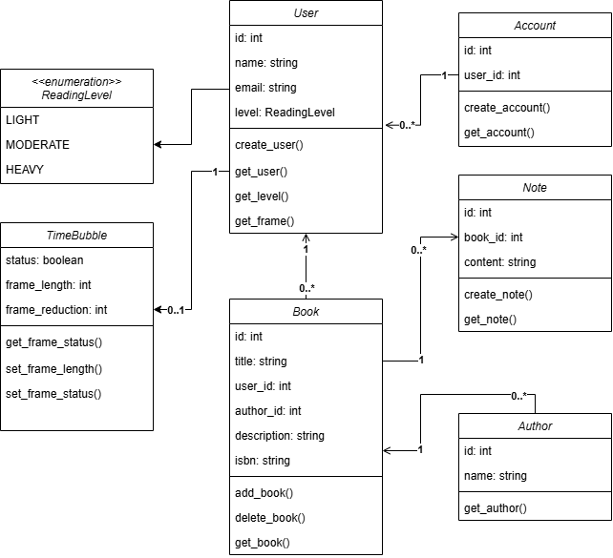

1. **Class Diagram**
2. **Entity Relationship Diagram**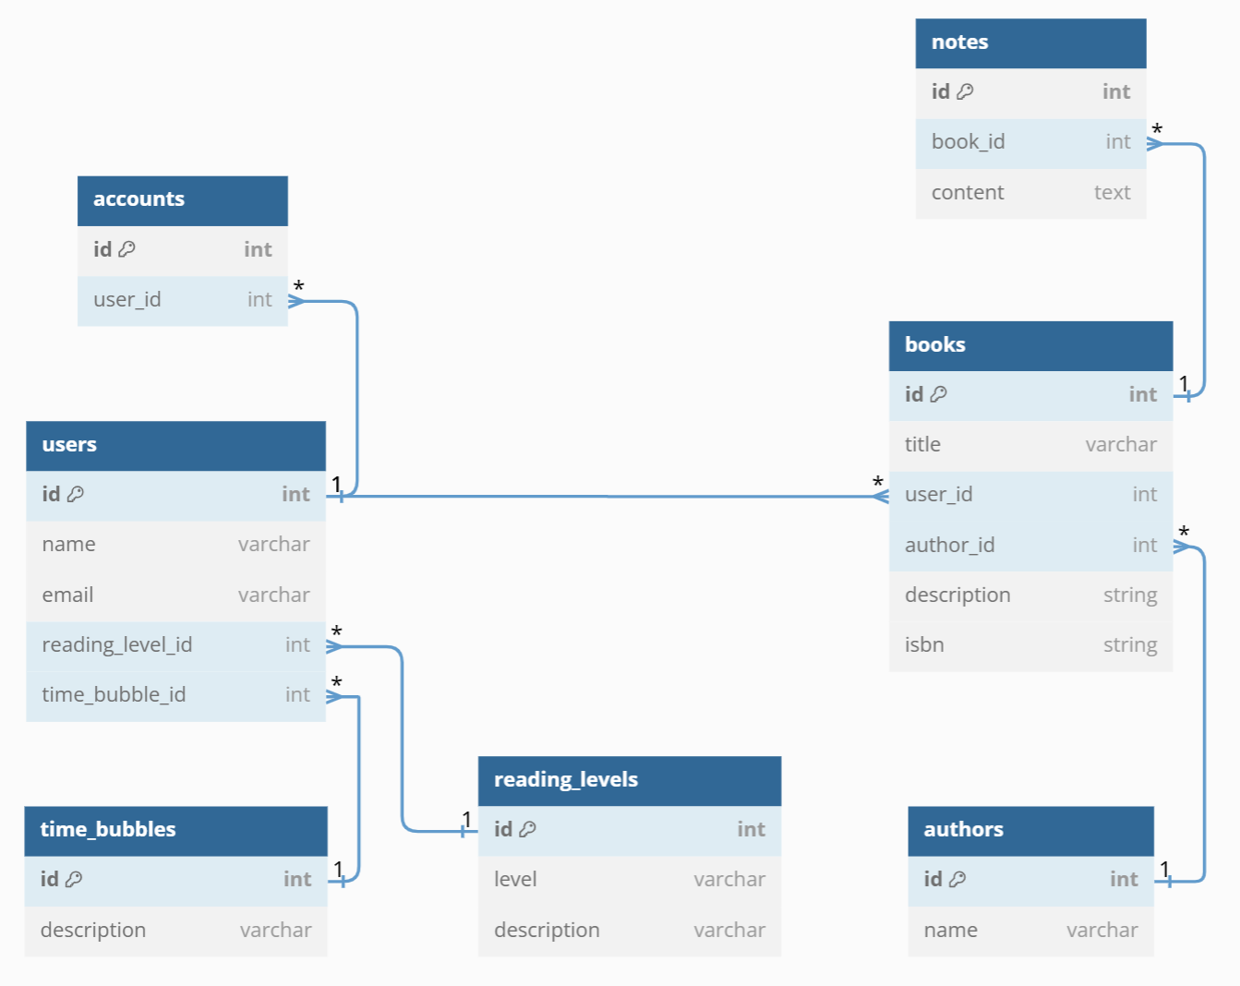

*draw.io: Entity Relationship Diagram:*

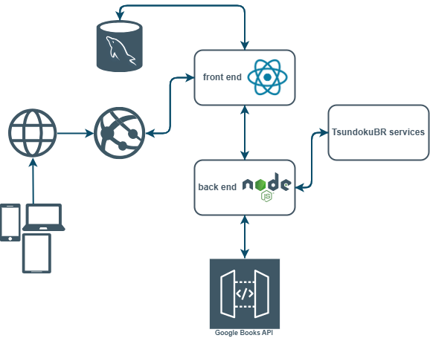

1. **Architecture Diagram**

*draw.io: Architecture Diagram:*

1. 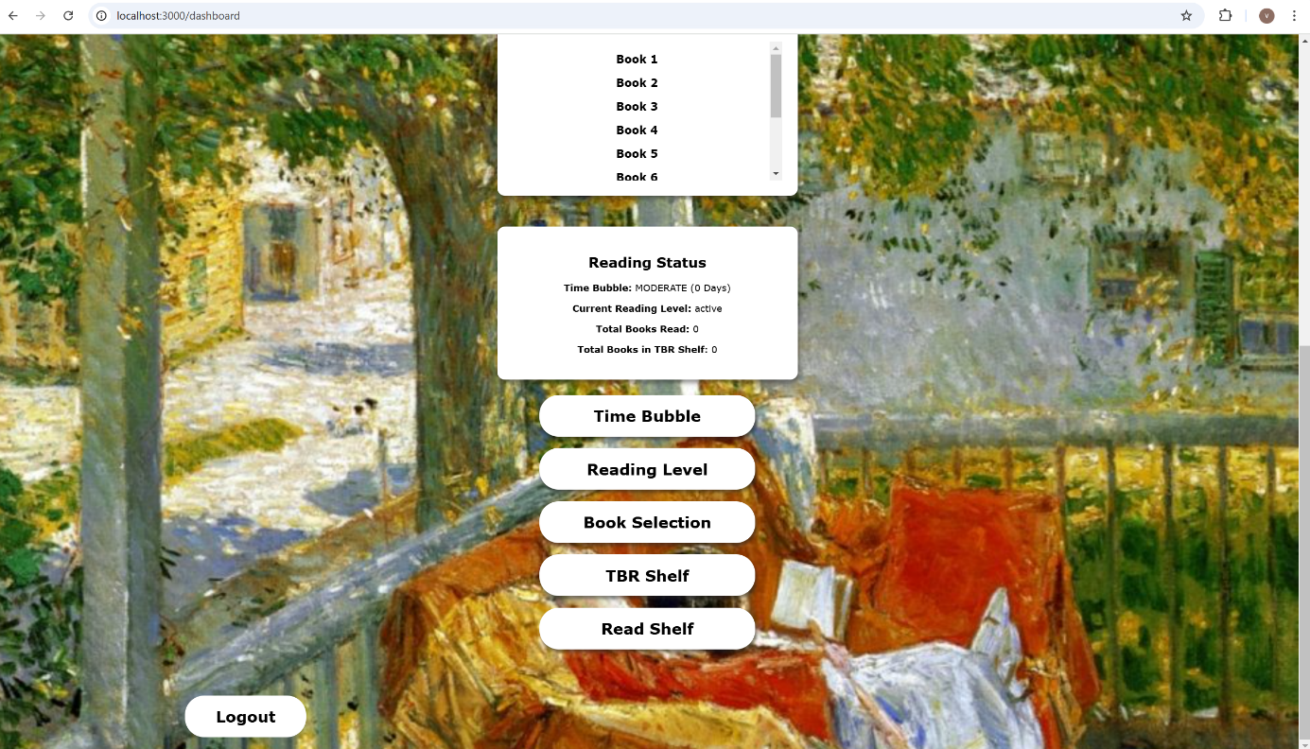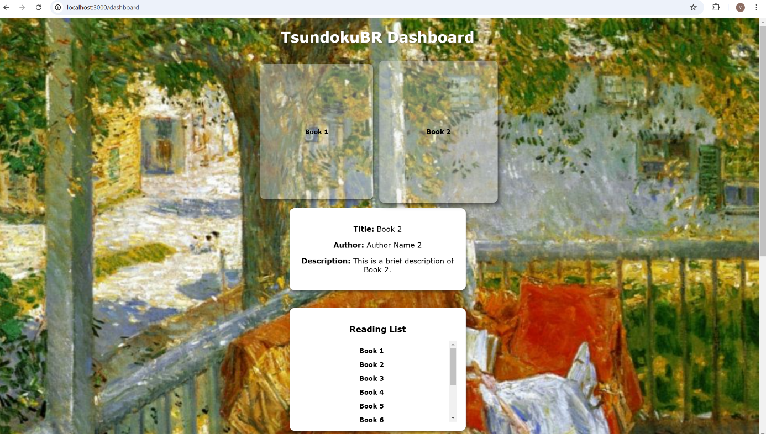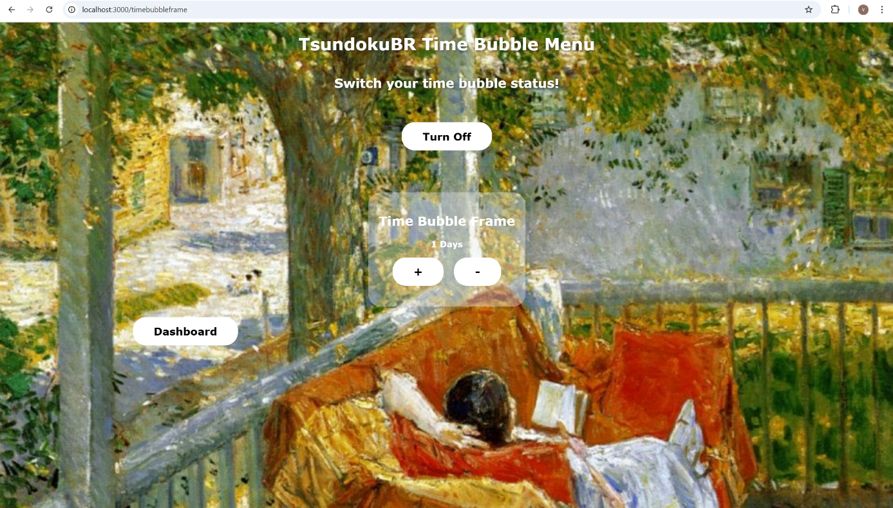**Implementation Screenshots**

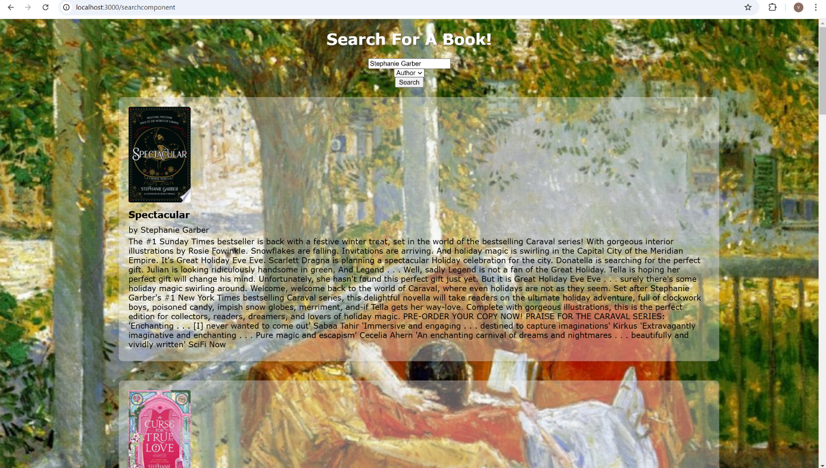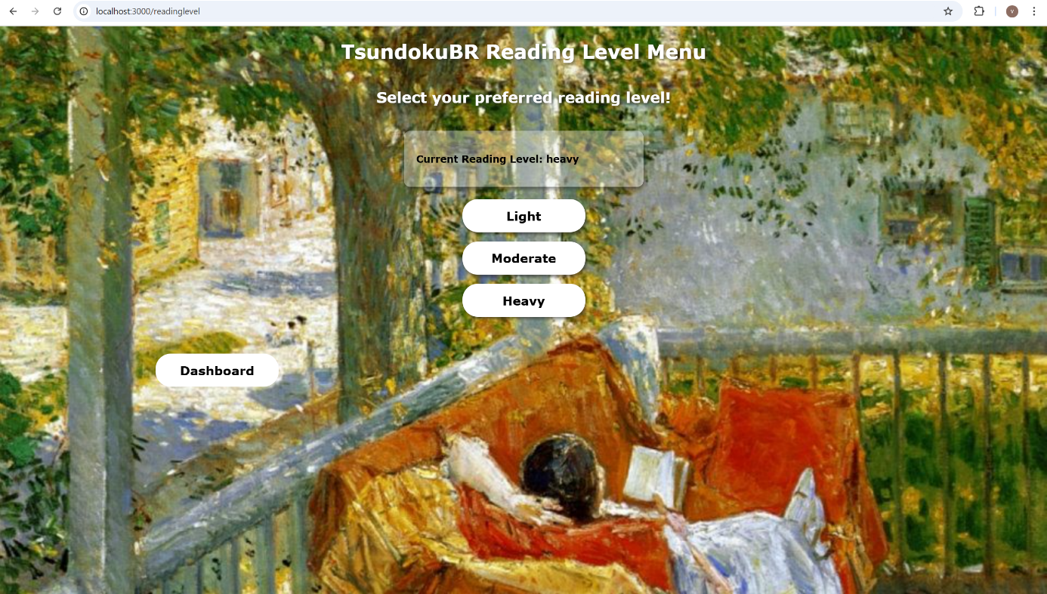

1. **Testing**

*Test Case Table Continuation:*

|  |  |  |  |  |  |  |  |
| --- | --- | --- | --- | --- | --- | --- | --- |
| **Test ID** | **Test Name** | **Test Inputs** | | **Expected Result** | **Actual Result** | **Status** | **Comments** |
| BUBBLE_003 | validate should check that bubble time frame when off should have a count of 0 | NA | | off  0 | off  0 | PASS | NA |
| **Prerequisites** | * Bubble Time Frame is switched on. | | | | | | |
| **Test Steps** | 1. Navigate to “Time Bubble Frame” Page. 2. Select “off” button | | | | | | |
| **Test ID** | **Test Name** | **Test Inputs** | | **Expected Result** | **Actual Result** | **Status** | **Comments** |
| BUBBLE_004 | incrementCount should increase the bubble time frame count | NA | | on  2 | on  2 | PASS | count at the start was 1. |
| **Prerequisites** | * Bubble Time Frame is switched on. | | | | | | |
| **Test Steps** | 1. Navigate to “Time Bubble Frame” Page. 2. Select “+” button. | | | | | | |
| **Test ID** | **Test Name** | **Test Inputs** | | **Expected Result** | **Actual Result** | **Status** | **Comments** |
| BUBBLE_005 | decrementCount should decrease the bubble time frame count | NA | | on  4 | on  4 | PASS | count at the start was 5. |
| **Prerequisites** | * Bubble Time Frame is switched on. | | | | | | |
| **Test Steps** | 1. Navigate to “Time Bubble Frame” Page. 2. Select “-“ button. | | | | | | |
| **Test ID** | **Test Name** | **Test Inputs** | | **Expected Result** | **Actual Result** | **Status** | **Comments** |
| BUBBLE_006 | decrementCountDaily should decrease the bubble time frame count if lastDecrementDate is true | NA | | on  4 | on  4 | PASS | count at the start was 5. |
| **Prerequisites** | * Bubble Time Frame is switched on. | | | | | | |
| **Test Steps** | NA | | | | | | |
| **Test ID** | **Test Name** | **Test Inputs** | | **Expected Result** | **Actual Result** | **Status** | **Comments** |
| USER_001 | User constructor with valid parameters should successfully create a User instance | 1  LIGHT  On  1  0  0 | | 1  LIGHT  On  1  0  0 | 1  LIGHT  On  1  0  0 | PASS | NA |
| **Prerequisites** | * Time Bubble Frame and Reading Level must be set up before User data for the constructor can be set up. | | | | | | |
| **Test Steps** | NA | | | | | | |
| **Test ID** | **Test Name** | **Test Inputs** | | **Expected Result** | **Actual Result** | **Status** | **Comments** |
| USER_002 | updateReadingLevelStatus should update the reading level status of the user when a different level is selected | 1  Moderate | | 1  Moderate | 1  Moderate | PASS | NA |
| **Prerequisites** | * Valid Reading Level status is already linked to the user | | | | | | |
| **Test Steps** | 1. Navigate to “Reading Level Menu” page. 2. Select the different button levels. | | | | | | |
| **Test ID** | **Test Name** | | **Test Inputs** | **Expected Result** | **Actual Result** | **Status** | **Comments** |
| USER_003 | updateTimeBubbleStatus should update timeBubbleStatus and reset timeBubbleCount if status is "off" | | NA | off  0 | off  0 | PASS | NA |
| **Prerequisites** | * Time bubble status was on and count was greater or equal to one. | | | | | | |
| **Test Steps** | 1. Navigate to “Time Bubble Menu” Page 2. Select “off” button. | | | | | | |
| **Test ID** | **Test Name** | | **Test Inputs** | **Expected Result** | **Actual Result** | **Status** | **Comments** |
| USER_004 | incrementTimeBubbleCount should increase the count of the user bubble frame | | 1  LIGHT  On  5  0 | 1  LIGHT  On  6  0 | 1  LIGHT  On  6  0 | PASS | NA |
| **Prerequisites** | * Time Bubble Frame status should be set to on. | | | | | | |
| **Test Steps** | 1. Navigate to “Time Bubble Menu” Page 2. Select “+” button. | | | | | | |
| **Test ID** | **Test Name** | | **Test Inputs** | **Expected Result** | **Actual Result** | **Status** | **Comments** |
| USER_005 | decrementTimeBubbleCount should decrease the count of the user bubble frame | | 1  LIGHT  On  5  0 | 1  LIGHT  On  4  0 | 1  LIGHT  On  4  0 | PASS | NA |
| **Prerequisites** | * Time Bubble Frame status should be set to o | | | | | | |
| **Test Steps** | 1. Navigate to “Time Bubble Menu” Page 2. Select “-” button. | | | | | | |

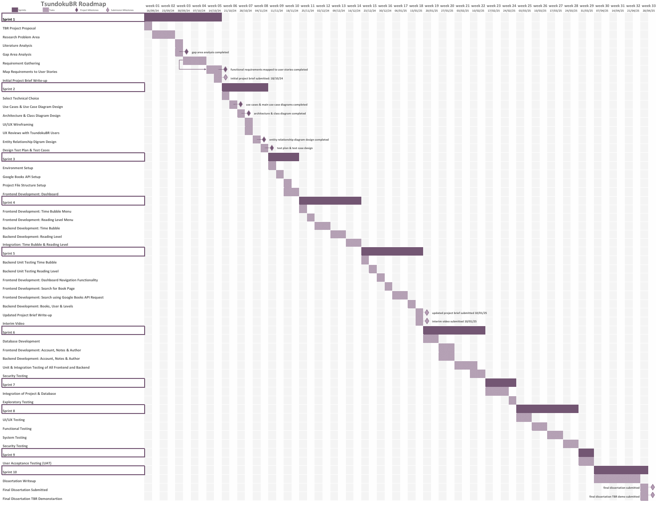

## **References**

1. Felice, B.B. (2024). Booktok and the Growth of Culture of Reading. [PDF] pp.1–60. Available at: https://scholarworks.calstate.edu/downloads/2b88qm397 [Accessed 1 Oct. 2024].
2. Ridzuan, M. (2023). The Phenomenon of Booktok and Its Impact on The Transformation of Literary Culture and The Publishing Industry. Forum Komunikasi, [online] 18(2), pp.74–83. Available at: https://forumkomunikasi.uitm.edu.my/images/FK18No2Oct23/FKOCT_2023_06_BOOKTOK.pdf [Accessed 1 Oct. 2024].
3. Cambridge English Dictionary. (n.d.). Tsundoku. Retrieved from https://dictionary.cambridge.org/dictionary/english/tsundoku
4. Da Col, G. (2015). Tsundoku. Hau: Journal of Ethnographic Theory, [online] 5(2), pp.1–3. Available at: https://www.journals.uchicago.edu/doi/epdf/10.14318/hau5.2.001 [Accessed 2 Oct. 2024].
5. Chernev, A., Böckenholt, U. and Goodman, J. (2015). Choice overload: A conceptual review and meta-analysis. Journal of Consumer Psychology, [online] 25(2), pp.333–358. Available at: [Accessed 2 Oct. 2024].
6. Perschak , K.E.M. (2017). Heavy Readers and Their Unread Books. Explaining a Common Habit. [online] Literacy in the New Landscape of Communication – Research, Education, and the Everyday. Conference Proceedings of the 19th European Conference on Literacy. Alpen-Adria-Universität Klagenfurt, Austria , pp.69–75. Available at: https://www.researchgate.net/profile/Katharina-Perschak-2/publication/328449798_Heavy_Readers_and_Their_Unread_Books_Explaining_a_Common_Habit/links/5bcee6de299bf1a43d9a6f24/Heavy-Readers-and-Their-Unread-Books-Explaining-a-Common-Habit.pdf [Accessed 2 Oct. 2024].
7. Ju, S., Lee, K.R., Kim, S. and Park. Y.W., (2019). Bookly: An Interactive Everyday Artifact Showing the Time of Physically Accumulated Reading Activity. In: CHI ’19: Proceedings of the 2019 CHI Conference on Human Factors in Computing Systems. [online] pp.1–8. Available at: https://dl.acm.org/doi/pdf/10.1145/3290605.3300614 [Accessed 1 Oct. 2024].
8. Gold, T.A. (2020). A BOOK CLUB FOR THE 21ST CENTURY: AN ETHNOGRAPHIC EXPLORATION OF BOOKTUBE. [PDF] pp.1–194. Available at: https://cdr.lib.unc.edu/concern/dissertations/2227mw07s [Accessed 2 Oct. 2024].
9. Apple (United Kingdom). (n.d.). App Store - Developing for the App Store. [online] Available at: https://www.apple.com/uk/app-store/developing-for-the-app-store/.
10. play.google. (n.d.). How Google Play Works. [online] Available at: https://play.google/howplayworks/.
11. Goodreads (2010). Goodreads: Book Reviews. [online] App Store. Available at: https://apps.apple.com/gb/app/goodreads-book-reviews/id355833469 [Accessed 6 Oct. 2024].
12. Fable (2021). Fable: Books & TV. [online] App Store. Available at: https://apDamir Juretic (2019). Bookshelf-Your virtual library. [online] App Store. Available at: https://apps.apple.com/gb/app/bookshelf-your-virtual-library/id1464032274 [Accessed 6 Oct. 2024].
13. ps.apple.com/gb/app/fable-books-tv/id1488170618 [Accessed 6 Oct. 2024].
14. Games, T. (2016). Bookly - TBR Book Tracker. [online] App Store. Available at: https://apps.apple.com/gb/app/bookly-tbr-book-tracker/id1085047737 [Accessed 6 Oct. 2024].
15. Dong su Mun (2020). Bookmory - book tracker & TBR. [online] App Store. Available at: https://apps.apple.com/gb/app/bookmory-book-tracker-tbr/id1515533482 [Accessed 6 Oct. 2024].
16. Laplante, P. A. & Kassab, M., 2022. Requirements Engineering for Software and Systems. 4th ed.
17. Google (2019). Google Forms: Free Online Surveys for Personal Use. [online] Google.co.uk. Available at: https://www.google.co.uk/forms/about/.
18. Agile Business Consortium (2014). DSDM Project Framework. [online] www.agilebusiness.org. Available at: https://www.agilebusiness.org/dsdm-project-framework.html.
19. Sommerville, I. (2016). Software engineering. 10th ed. Pearson
20. Initiative (WAI), W.W.A. (2023). Accessibility Fundamentals Overview. [online] Web Accessibility Initiative (WAI). Available at: https://www.w3.org/WAI/fundamentals/.
21. T, W. (2019). SUS Calculator. [online] UIUX Trend. Available at: https://uiuxtrend.com/sus-calculator/#google_vignette.
22. GeeksforGeeks. (2023). Web Development. [online] Available at: https://www.geeksforgeeks.org/web-development/?ref=home-articlecards.
23. www.w3schools.com. (n.d.). Web Development. [online] Available at: https://www.w3schools.com/whatis/default.asp.
24. survey.stackoverflow.co. (n.d.). 2024 Stack Overflow Developer Survey. [online] Available at: https://survey.stackoverflow.co/2024/.
25. Meta Open Source (2024). React. [online] react.dev. Available at: https://react.dev/.
26. react-bootstrap.netlify.app. (n.d.). React Bootstrap | React Bootstrap. [online] Available at: https://react-bootstrap.netlify.app/.
27. Node.js (2023). Node.js. [online] Node.js. Available at: https://nodejs.org/en.
28. expressjs.com. (n.d.). Express 4.x - API Reference. [online] Available at: https://expressjs.com/en/4x/api.html.
29. Oracle (2024). MySQL. [online] Mysql.com. Available at: https://www.mysql.com/.
30. Google Developers. (n.d.). Google Books APIs. [online] Available at: https://developers.google.com/books.
31. Microsoft (2024). Visual Studio Code. [online] Visualstudio.com. Available at: https://code.visualstudio.com/.
32. Canziba, E. (2018). Hands-on UX design for developers : design, prototype, and implement compelling user experiences from scratch. Birmingham, Uk: Packt Publishing.
33. draw.io (2024). Flowchart Maker & Online Diagram Software. [online] app.diagrams.net. Available at: https://app.diagrams.net/.
34. Figma (2024). Figma: the Collaborative Interface Design tool. [online] Figma. Available at: https://www.figma.com/.
35. GeeksforGeeks (2023). Use Case Diagram. [online] GeeksforGeeks. Available at: https://www.geeksforgeeks.org/use-case-diagram/.
36. www.ibm.com. (n.d.). Defining use cases. [online] Available at: https://www.ibm.com/docs/en/product-master/12.0.0?topic=processes-defining-use-cases.
37. GeeksforGeeks (2018). Class Diagram | Unified Modeling Language (UML). [online] GeeksforGeeks. Available at: https://www.geeksforgeeks.org/unified-modeling-language-uml-class-diagrams/?ref=header_outind [Accessed 28 Oct. 2024].
38. dbdiagram.io. (n.d.). dbdiagram.io - Database Relationship Diagrams Design Tool. [online] Available at: https://dbdiagram.io/home.
39. GeeksforGeeks (2024). How to Draw Entity Relationship Diagrams (ERDs). [online] GeeksforGeeks. Available at: https://www.geeksforgeeks.org/how-to-draw-entity-relationship-diagrams/?ref=header_outind [Accessed 28 Oct. 2024].
40. GeeksforGeeks (2024). Data Architecture Diagrams. [online] GeeksforGeeks. Available at: https://www.geeksforgeeks.org/data-architecture-diagrams/?ref=header_outind [Accessed 28 Oct. 2024].
41. singhsonalmeenu (2022). Benefits of Software Testing. [online] GeeksforGeeks. Available at: <https://www.geeksforgeeks.org/benefits-of-software-testing/>.
42. GeeksforGeeks (2022). How to write Test Cases Software Testing. [online] GeeksforGeeks. Available at: <https://www.geeksforgeeks.org/test-case/?ref=header_outind>.
43. docs.gitlab.com. (n.d.). CI/CD pipelines | GitLab. [online] Available at: https://docs.gitlab.com/ee/ci/pipelines/.
44. confluence.atlassian.com. (n.d.). Jira Software Documentation | Atlassian Support | Atlassian Documentation. [online] Available at: <https://confluence.atlassian.com/jirasoftware/jira-software-documentation-774242447.html>.

**Use of Generative AI for my TsundokuBR web application project:**

[1] Microsoft.com. (2025). *Start Your Copilot Journey | Microsoft Copilot*. [online] Available at: https://www.microsoft.com/en-gb/microsoft-copilot/meet-copilot? [Accessed 8 Jan. 2025].

[2] OpenAI (2022). *ChatGPT*. [online] Openai.com. Available at: https://openai.com/index/chatgpt/.

**The use of generative AI for my project has aided me and my project to help increase efficiency for tool installation, understanding errors that I have received while developing my project, the comparison of technology dev tools, explanation of terms that I require, etc…**